

**DBA Open Ended Experiment Project Report On**

**CRICKET WORLD CUP DATABASE MANAGEMENT SYSTEM**

**Team Number: 4**

**List of Team Members:**

|  |  |  |
| --- | --- | --- |
| **USN** | **ROLL NO** | **NAME** |
| **01FE19BCS304** | **533** | Raghavendra A H |
| **01FE19BCS279** | **512** | Shreehari T Alagawadi |
| **01FE19BCS275** | **534** | Bhuavn M C |
| **01FE19BCS290** | **522** | Supriya Khemalapure |

**Content**

|  |  |  |  |
| --- | --- | --- | --- |
|  | | Title | Page No |
| 1 | | Introduction | 3-4 |
|  | 1.1 | Cricket WorldCup | 3 |
|  | 1.2 | Database Management System | 3 |
|  | 1.3 | Problem Statement | 4 |
|  | 1.4 | Objectives | 4 |
|  | 1.5 | Motivation | 4 |
|  | | | |
| 2 | | Requirement Collection and Analysis | 5-6 |
|  | 2.1 | Introduction | 5 |
|  | 2.2 | Data Requirement | 5 |
|  | 2.3 | Functional Requirement | 5 |
|  | 2.4 | Non Functional Requirement | 6 |
|  | | | |
| 3 | | Database Design | 7-16 |
|  | 3.1 | Introduction | 7 |
|  | 3.2 | Conceptual Design | 7 |
|  | 3.3 | Logical Database Design | 8-10 |
|  | 3.4 | Physical Database Design | 10-16 |
|  | | | |
| 4 | | Implementation and Results | 16-94 |
|  | 4.1 | Introduction | 16-53 |
|  | 4.2 | Database | 53-76 |
|  | 4.3 | GUI Implementation | 76-94 |

**Chapter 1: Introduction**

* 1. **Flower Bouquet Shop Management**

The Cricket World Cup is the international championship of One Day International (ODI) cricket. The event is organised by the sport's governing body, the International Cricket Council (ICC), every four years, with first qualification rounds leading up to a semifinals and then finals tournament. The tournament is one of the world's most viewed sporting events. The World Cup is open to all members of the International Cricket Council (ICC), although the highest-ranking teams receive automatic qualification. The remaining teams are determined via the World Cricket League and the ICC World Cup Qualifier. A total of twenty teams have competed in the eleven editions of the tournament, with fourteen teams competing in 2015; the recent 2019 tournament only had ten teams. Australia has won the tournament five times, India and West Indies twice each, while Pakistan, Sri Lanka and England have won it once each. The best performance by a non-full-member team came when Kenya made the semi-finals of the 2003 tournament.

The project titled “CRICKET WORLD CUP DATABASE MANAGEMENT SYSTEM” is a comprehensive system which provide all the information about World cup. This project deals with the scheduling matches,, updating their results ,disqualifying a player or a team and adding ,updating ,deleting of data related to worldcup by an authorized person.

**1.2 Database Management System**

Formally, a "database" refers to a set of related data and the way it is organized.Access to this data is usually provided by a "database management system" (DBMS). It consists of an integrated set ofcomputer software that allows users to interact withone or more databases and provides access to all of the data contained in the database(although restrictions may exist that limit access to particular data). The DBMS providesvarious functions that allow entry, storage and retrieval of large quantities of informationand provides ways to manage how that information is organized.

DBMSs provide various functions that allow management of a database and its datawhich can be classified into four main functional groups:

* **Data definition** – Creation, modification and removal of definitions that define the organization of the data
* **Update** – Insertion, modification, and deletion of the actual data
* **Retrieval** – Providing information in a form directly usable or for further processing by other applications. The retrieved data may be made available in a form basically the same as it is stored in the database or in a new form obtained by altering or combining existing data from the database
* **Administration** – Registering and monitoring users, enforcing data security, monitoring performance, maintaining data integrity, dealing with concurrency control, and recovering information that has been corrupted by some event such as an unexpected system failure

**Relational Database Management System (RDBMS)**

RDBMS is a database management system (DBMS) based on the relational model of data. Most databases in widespread use today are based on this model. RDBMSs have been a common option for the storage of information in databases used for financial records, manufacturing and logistical information, personnel data, and other applications since the 1980s. Relational databases have often replaced legacy data models like hierarchical databases and network databases because they were easier to implement and administer. Nonetheless, relational databases received continued, unsuccessful challenges by object database management systems in the 1980s and 1990s, (which were introduced in an attempt to address the so-called object-relational impedance mismatch between relational databases and object-oriented application programs), as well as by XML database management systems in the 1990s.However, due to the expanse of technologies, such as horizontal scaling of computer clusters, No SQL databases have recently become popular as an alternative to RDBMS databases.

**1.3 Problem Statement**

This project aims to design and implement the database to maintain the data related to cricket World Cup.

**1.4 Objectives of the Project**

The objectives of our project of Cricket World Cup database management system are:

* Systematic storage of all the data and try to avoid the redundancy
* Using the basic concepts of database management system
* To thoroughly study the concepts and applications of database systems while implementing
* Properly making use of the database design concepts to implement the system
* Using *structured query language* for implementation

**1.5 Motivation**

In India there are many people including our project team who are very interested in cricket than anything else. Cricket World Cup is the tournament for which cricket fans are very much exited. Therefore we decided to create a GUI where anyone can get any information they want about world cup. To make the life of the one who maintains data we also decided to implementfeatures like scheduling matches etc. Itwould be really helpingboth cricket fans and also the team which maintains the data.

**Chapter 2: Requirement Collection and Analysis**

* 1. **Introduction**

The most critical aspect of specification is the gathering and compilation of system anduser requirements. This process is normally done in conjunction with managers andusers.

The major goal in requirements gathering process is to:

* Collect the data used by the organization
* Identify relationships/conditions to be applied on the data
* Identify future data needs
* Determine how the data is used and generated
* Identify the functions that are performed on the data
  1. **Data Requirements**
* A Team is identified by team id, country name, number of batsmen and number of bowlers.
* A player is identified by player id, name, type of the player, number of matches he has played which includes test matches t20s and ODIs.
* Batsman is identified by Player id, number of sixes and four hit, batting average and total runs scored.
* Bowler has player id, type of bowler, highest speed, number of wickets and economy.
* Umpire has a umpire Id, name, country, number of matches and his experience.
* Coach has ID, name, country, type(batting or bowling) and experience in years.
* Captain is a player and has a name, number of years of captaincy, number of wins and number of trophies won in his captaincy.
* Matches are played between 2 teams in a stadium on a specific date and time with 3 umpires.
* Result has winner team, loser team, man of the match and won by wickets or runs.
* Stadium has name, pitch type, capacity, highest score in that stadium.
  1. **Functional Requirements**

1. Retrieval of data by user:

Any users must be able to retrieve the information they want.

• View all teams.

• View all players of a team.

• View all batsmen in the tournament.

• View all bowlers in the tournament.

• View all match reports .

• View present statistics of a player .

• View coach details.

• View umpire details.

• View Match details.

• View ranking of each team and view many more data.

Administrator : He has the authority to add, modify and deleting data.

2. Disqualification of a player or a team .

3. Scheduling match between 2 teams on specific date and time.

4. Updating of result of the matches scheduled.

5. Ranks should be automatically updated when result is updated

* Team has n Players (1:N)
* Team can be coached by n Coaches(1:N)
* M team plays n match(M:N)
* Team has a rank in Points table(1:1)
* Team has a single Captain(1:1)
* Matches are umpired by n Umpire(M:N)
* N matches are played in a Stadium(N:1)
* Match has a result(1:1)
* A player is man of the match in match result(1:1)
* A team is winner in match result.(1:1)
  1. **Non Functional Requirements**

Non-functional Requirements (NFRs) define system attributes such as security, reliability, performance, maintainability, scalability, and usability. They serve as constraints or restrictions on the design of the system.

**Chapter 3: Database Design**

**3.1 Introduction**

Database design is the organization of data according to a database model. The designer determines what data must be stored and how the data elements interrelate. With this information, they can begin to fit the data to the database model. Database management system manages the data accordingly. Database design involves classifying data and identifying interrelationships.

Since the design process is complicated, especially for large databases, database design is divided into three phases:

* Conceptual database design
* Logical database design
* Physical database design
  1. **Conceptual Database Design**

Conceptual design is the first stage in the database design process. The goal at this stage is to design a database that is independent of database software and physical details. The output of this process is a conceptual data model that describes the main data entities, attributes, relationships, and constraints of a given problem domain.

1. **Team**: Attributes : CountryName,Team ID , Number of Batsmen and Number of Bowlers.
2. **Player:** Attributes: player_id, player_name, dob, gender, number of matches ( type_of_player,no_of_tests, no_of_t20s, no_of_ODIs) , team_id.
3. **Batsman**: Attributes:player_id, batsman_type, number_of_sixes, number_of_fours, total_runs, highest_runs, batting_average.
4. **Bowler** : Attributes: player_id , bowler_type, number_of_wickets, highest_speed, economy.
5. **Coach** : Attributes: coach_id, team_id, coach_name, coach_country, coach_type, coach_experience.
6. **Captain** : Attributes: team_id, player id, name, years_of_captaincy, number_of_wins, number_of_trophies.
7. **Stadium :** Attributes: stadium_id, stadium_name, pitch_type, scapacity, matches_in_std.
8. **Matches**: Attributes: match_id, Team1_id, Team2_id, stadium_id, match_date_time.
9. **Points_table :** Attributes**:** Team_id, number_of_wins, number_of_loss,number_of_draw, points, run_rate, team_rank.
10. **Umpired_by :** Attributes**:**match_id, u_id.
11. **Results :** Attributes:Result_id, match_id, winner_team, won_by_runs_or_wickets, man_of_the_match.
    1. **Logical Database Design**

Logical database design is the process of deciding how to arrange the attributes of the entities in a given business environment into database structures, such as the tables of a relational database.

* + 1. **Entity Relationship Diagram (ER Model)**

ER model stands for an Entity-Relationship model. It is a high-level data model. This model is used to define the data elements and relationship for a specified system. It develops a conceptual design for the database. It also develops a very simple and easy to design view of data. In ER modeling, the database structure is portrayed as a diagram called an entity-relationship diagram.

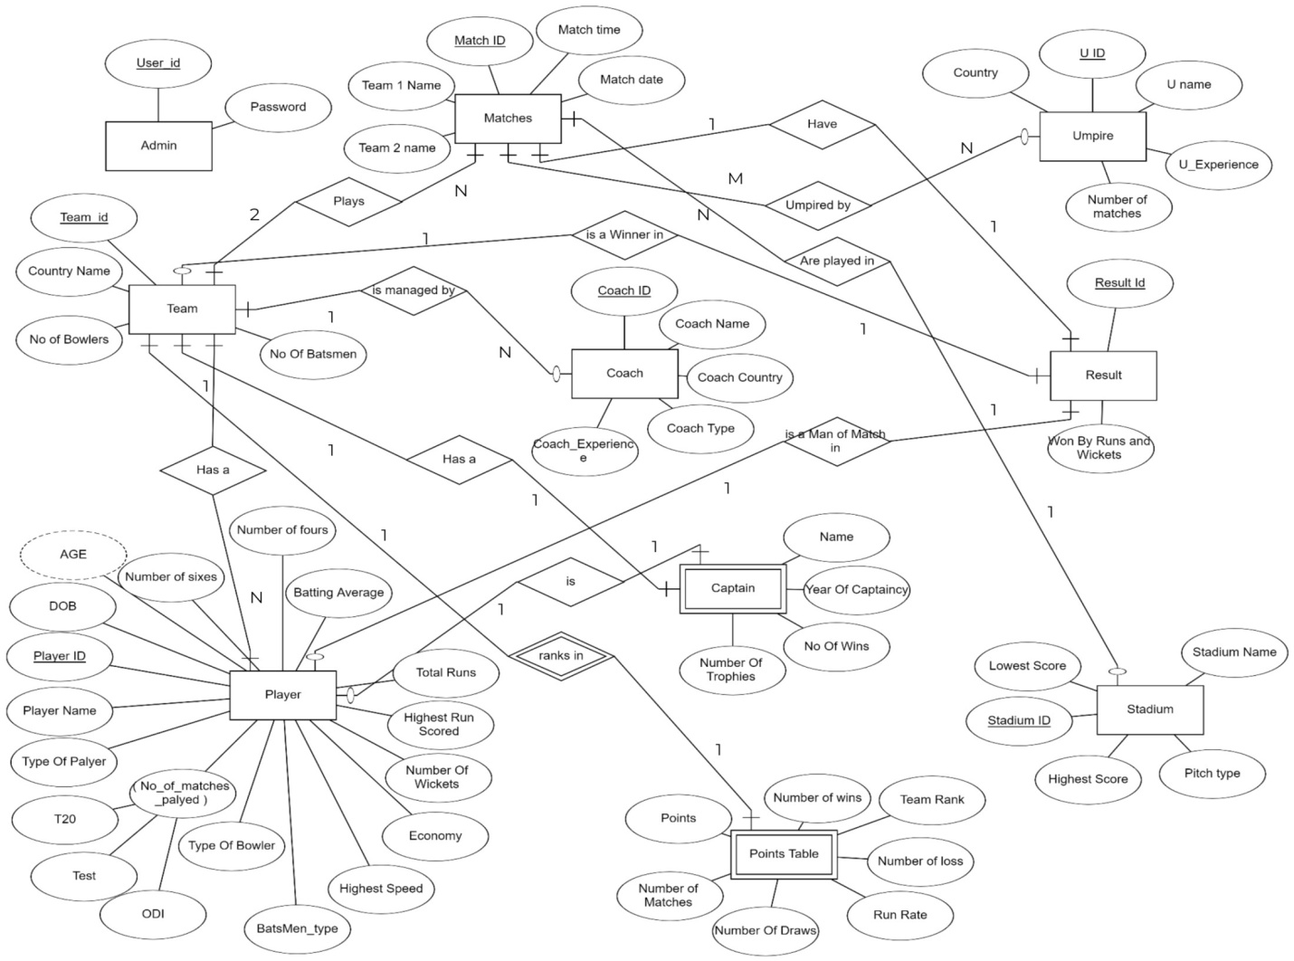

* + 1. **ER to Relational Schema Conversion**

1. **Entity set:**

To convert this entity set into relational schema,   
1.Entity is mapped as relation in Relational schema.  
2. Attributes of Entity set are mapped as attributes for that Relation.  
3. Key attribute of Entity becomes Primary key for that Relation.

1. **Entity set with multi valued attributes:**

To convert entity with multi valued attribute into relational schema,   
separate relation is created for multi valued attribute in which  
1.Key attribute and multi valued attribute of entity set becomes primary key of relation.  
2. Separate relation employee is created with remaining attributes.  
Due to this instead of repeating all attributes of entity now only one attribute is need to repeat.

1. **Entity set with composite attributes:**

In this case to convert entity into relational schema,

1. Composite attribute student name should not be include in relation but all parts of composite attribute are mapped as simple attributes for relation.

1. **1:M (One to Many) Relationship:**

In this case to convert this relationship into relational schema,   
1.Separate relation is created for all participating entity sets.  
2. Key attribute of Many’s side entity set is mapped as foreign key in one’s side relation.  
3. All attributes of relationship set are mapped as attributes for relation of one’s side entity set.

1. **M:1 (Many to One) Relationship:**

To convert this relationship set into relational schema,   
1.Separate relation is created for all participating entity sets.  
2.Key attribute of Many’s side entity set student is mapped as foreign key in one’s side relation  
3.All attributes of relationship set are mapped as attributes for one’s side relation course.

1. **M:N (Many to Many) Relationship:**

To convert this Relationship set into relational schema,   
1.Relationship set is mapped as separate relation.  
2.Key attributes of participating entity sets are mapped as primary key for that relation.  
3.Attribute of relationship set becomes simple attributes for that relation.  
4. Separate relation is created for other participating entities.

1. **1:1 (One to One) Relationship:**

To convert this Relationship set into relational schema,

1. Separate relation is created for all participating entity sets.

2. Primary Key of one relation can be act as foreign key for another relation.

* 1. **Physical Database Design**

The physical design of your database optimizes performance while ensuring data integrity by avoiding unnecessary data redundancies. During physical design, you transform the entities into tables, the instances into rows, and the attributes into columns.

**3.4.1Relational Schema**

Relational Model represents how data is stored in Relational Databases.  A relational database stores data in the form of relations (tables)

If we consider Player table, player is either a batsman or bowler or all rounder Hence some values becomes null if player is only batsmen or only bowler.

Player { player id, player name, dob, type of player, no of tests, no of matches, team id, batsman type, number of sixes, number of fours, total runs, highest runs, batting average, bowler type, number of wickets, highest speed, economy }

To avoid null values Player table is further divided into 3 tables

* Player { player id, player name, dob, type of player, no of matches, team id }
* Batsman { player id, batsman type, number of sixes, number of fours, total runs, highest runs, batting average }
* Bowler { player id, bowler type, number of wickets, highest speed, economy }

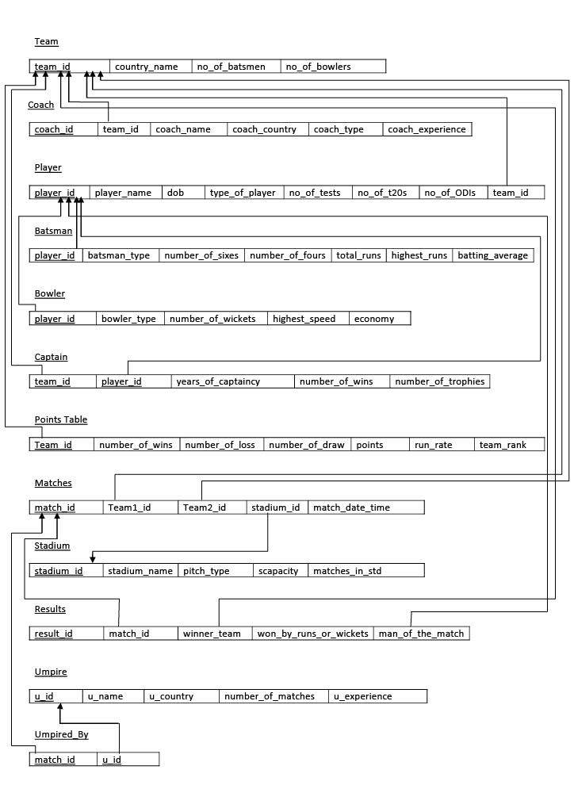

**3.4.2 Normalization**

**Normalization** is a process of organizing the data in database to avoid data redundancy, insertion anomaly, update anomaly & deletion anomaly

**1NF:**A relation is in 1NF if it contains an atomic value.

**2NF:**A relation will be in 2NF if it is in 1NF and all non-key attributes are fully functional dependent on the primary key.

**3NF:**A relation will be in 3NF if it is in 2NF and no transition dependency exists.

**Team** (Country Name ,Team ID , Number of Batsmen and Number of Bowlers.)

1.The relation is in 1NF as it has atomic valued attributes.  
2.The relation is in 2NF since, every attribute is fully functionally dependent on the key.  
3.There is no transitivity in functional dependencies for this relation. Hence the relation is in 3NF.

**Player(**player_id, player_name, dob, gender, type_of_player, number_of_matches (no_of_tests, no_of_t20s, no_of_ODIs), team_id)

1.Player table has a composite attribute number of matches comprising of no of tests, no of t20s, no of ODIs . This violates 1NF form.

Divide composite value into simple attributes - no of tests, no of t20s, no of ODIs .

**Player** ( player id, player name, dob, type of player, no of tests, no of t20s, no of ODIs, team id).

Now player team converted to 1NF.

2.The relation is in 2NF since, every attribute is fully functionally dependent on the key.

3.There is no transitivity in functional dependencies for this relation. Hence the relation is in 3NF.

**Batsman** ( player_id, batsman_type, number_of_sixes, number_of_fours, total_runs, highest_runs, batting_average)

1.The relation is in 1NF as it has atomic valued attributes.

2.The relation is in 2NF since, every attribute is fully functionally dependent on the key.

3.There is no transitivity in functional dependencies for this relation. Hence the relation is in 3NF.

**Bowler** ( player_id , bowler_type, number_of_wickets, highest_speed, economy)

1.The relation is in 1NF as it has atomic valued attributes)

2.The relation is in 2NF since, every attribute is fully functionally dependent on the key.

3.There is no transitivity in functional dependencies for this relation. Hence the relation is in 3NF.

**Coach** (coach_id, team_id, coach_name, coach_country, coach_type, coach_experience)

1.The relation is in 1NF as it has atomic valued attributes.

2.The relation is in 2NF since, every attribute is fully functionally dependent on the key.

3.There is no transitivity in functional dependencies for this relation. Hence the relation is in 3NF.

**Captain** ( team_id, player id, name, years_of_captaincy, number_of_wins, number_of_trophies.

1.The relation is in 1NF as it has atomic valued attributes)

2.The relation is in 2NF since, every attribute is fully functionally dependent on the key.

3.There is no transitivity in functional dependencies for this relation. Hence the relation is in 3NF.

**Stadium** ( stadium_id, stadium_name, pitch_type, scapacity, matches_in_std)

1.The relation is in 1NF as it has atomic valued attributes.

2.The relation is in 2NF since, every attribute is fully functionally dependent on the key.

3.There is no transitivity in functional dependencies for this relation. Hence the relation is in 3NF.

**Matches** ( match_id, Team1_id, Team2_id, stadium_id, match_date_time)

1.The relation is in 1NF as it has atomic valued attributes.

2.The relation is in 2NF since, every attribute is fully functionally dependent on the key.

3.There is no transitivity in functional dependencies for this relation. Hence the relation is in 3NF.

**Points_table (** Team_id, number_of_wins, number_of_loss, number_of_draw, points, run_rate, team_rank.**)**

1.The relation is in 1NF as it has atomic valued attributes.

2.The relation is in 2NF since, every attribute is fully functionally dependent on the key.

3.There is no transitivity in functional dependencies for this relation. Hence the relation is in 3NF.

**Umpired_by (** match_id, u_id )

1.The relation is in 1NF as it has atomic valued attributes.

2.The relation is in 2NF since, every attribute is fully functionally dependent on the key.

3.There is no transitivity in functional dependencies for this relation. Hence the relation is in 3NF.

**Results (**Result_id, match_id, winner_team, won_by_runs_or_wickets, man_of_the_match)

1.The relation is in 1NF as it has atomic valued attributes.

2.The relation is in 2NF since, every attribute is fully functionally dependent on the key.

3.There is no transitivity in functional dependencies for this relation. Hence the relation is in 3NF.

**Chapter4.Implementation and Results**

**4.1 Introduction**

Implementation involves the construction of a database according to the specification ofa logical schema. This will include the specification of an appropriate storage schema, security enforcement, external schema and so on. Implementation is influenced by thechoice of available DBMSs, database tools and operating environment. There areadditional tasks beyond simply creating a database schema and implementing theconstraints such as data must be entered into the tables, issues relating to the usersand user processes need to be addressed, and the management activities associatedwith wider aspects of corporate data management need to be supported.

In practice, implementation of the logical schema in a given DBMS requires a verydetailed knowledge of the specific features and facilities that the DBMS has to offer. Inan ideal world, and in keeping with good software engineering practice, the first stage ofimplementation would involve matching the design requirements with the best availableimplementing tools and then using those tools for the implementation. In database terms, this might involve choosing vendor products with DBMS and SQL variants mostsuited to the database which is to be implemented. There are many relational DBMSs,available such as Oracle Database, Microsoft SQL Server, MySQL, IBM DB2, IBMInformix and Microsoft Access, use SQL. In this project we used Oracle SQL developercreate the tables of flower bouquet shop management database.

**4.2 Database: DDL, DML, Structured queries and PLSQL queries**

* 1. **Data Definition Language (DDL)**

DDL changes the structure of the table like creating a table, deleting a table, altering a table, etc. All the command of DDL are auto-committed that means it permanently save all the changes in the database.

* 1. **Data Manipulation Language (DML)**

DCL commands are used to grant and take back authority from any database user.

Here are some commands that come under DCL: grant, revoke.

**Grant:** It is used to give user access privileges to a database.

**Revoke:** It is used to take back permissions from the user.

* 1. **Data Control Language (DCL)**

TCL commands can only use with DML commands like INSERT, DELETE and UPDATE only.

These operations are automatically committed in the database that's why they cannot be used while creating tables or dropping them.

**Commit:** Commit command is used to save all the transactions to the database.

**Rollback:** Rollback command is used to undo transactions that have not already been saved to the database.

**SAVEPOINT:** It is used to roll the transaction back to a certain point without rolling back the entire transaction.

* 1. **Transaction Control Language (TCL)**

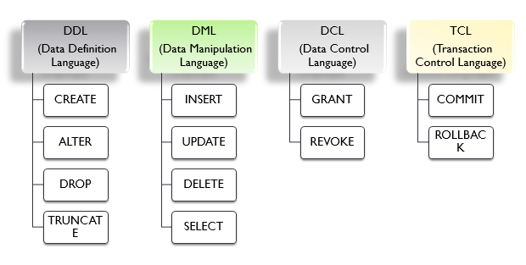

drop table team cascade constraints;

drop table player cascade constraints;

drop table batsman cascade constraints;

drop table bowler cascade constraints;

drop table umpire cascade constraints;

drop table coach cascade constraints;

drop table captain cascade constraints;

drop table matches cascade constraints;

drop table results cascade constraints;

drop table stadium cascade constraints;

drop table points_table cascade constraints;

drop table umpired_by cascade constraints;

create table team

(

team_id varchar2(30) primary key,

country_name varchar2(30),

no_of_batsmen number,

no_of_bowlers number

);

insert into team values('IND','India',8,8);

insert into team values('AFG','Afghanistan',7,9);

insert into team values('AUS','Austrelia',7,9);

insert into team values('BAN','Bangladesh',6,10);

insert into team values('ENG','England',8,8);

insert into team values('NZ','New Zealand',7,9);

insert into team values('PAK','Pakistan',6,10);

insert into team values('SA','South Africa',5,11);

insert into team values('SL','Shri Lanka',5,11);

insert into team values('WI','West Indies',6,10);

SELECT * FROM TEAM;

create table player

(

player_id varchar2(30) primary key,

player_name varchar2(30),

dob date,

type_of_player varchar2(30),

no_of_tests number,

no_of_t20s number,

no_of_ODIs number,

team_id varchar2(30) references team(team_id) on delete cascade

);

insert into player values('IND01','Virat Kohli','05-NOV-1988','Batsman',91,89,254,'IND');

insert into player values('IND02','Rohit Sharma','30-APR-1987','Batsman',38,111,227,'IND');

insert into player values('IND03','Mayank Agarwal','16-FEB-1991','Batsman',14,0,5,'IND');

insert into player values('IND04','K L Rahul','18-APR-1992','Batsman',36,48,38,'IND');

insert into player values('IND05','M S Dhoni','07-JULY-1981','Batsman',90,98,350,'IND');

insert into player values('IND06','Jasprit Bumrah','06-DEC-1993','Bowler',19,49,67,'IND');

insert into player values('IND07','Yuzvendra Chahal','03-july-1990','Bowler',0,48,54,'IND');

insert into player values('IND08','Ravindra Jadeja','06-dec-1988','Batsman',51,50,168,'IND');

insert into player values('IND09','Shikhar Dhawan','05-dec-1985','Batsman',34,64,142,'IND');

insert into player values('IND10','Bhuvneshwar Kumar','05-FEB-1990','Bowler',21,48,117,'IND');

insert into player values('IND11','Kuldeep Yadhav','14-DEC-1994','Bowler',7,20,63,'IND');

insert into player values('IND12','Rishabh Pant','10-MAR-1997','Batsman',30,20,300,'IND');

insert into player values('IND13','Kedar Jadhav','05-APR-1994','Batsman',25,20,63,'IND');

insert into player values('IND14','Hardik Pandya','05-DEC-1993','All Rounder',37,30,306,'IND');

insert into player values('IND15','Krunal Pandya','16-FEB-1995','All Rounder',37,30,145,'IND');

insert into player values('IND16','Harshal Patel','23-JUN-1996','Bowler',17,15,55,'IND');

delete from player where player_id='IND17';

insert into player values('AFG01','Hazartullah Zazai','23-mar-1998','Batsman',0,15,16,'AFG');

insert into player values('AFG02','Hashmatullah Shahidi','04-NOV-1994','Batsman',5,3,42,'AFG');

insert into player values('AFG03','Asghar Afghan','22-DEC-1987','Batsman',6,72,115,'AFG');

insert into player values('AFG04','Najibullah Zadran','28-FEB-1993','Batsman',0,63,70,'AFG');

insert into player values('AFG05','Noor Ali Zadran','10-JULY-1988','Batsman',0,19,51,'AFG');

insert into player values('AFG06','Dawlat Zadran','19-mar-1988','Bowler',0,34,82,'AFG');

insert into player values('AFG07','Mujeeb Ur Rahman','28-mar-2001','Bowler',1,19,43,'AFG');

insert into player values('AFG08','Aftab Alam','30-nov-1992','Bowler',0,13,27,'AFG');

insert into player values('AFG09','Hamid Hassan','01-june-1987','Bowler',0,21,39,'AFG');

insert into player values('AFG10','Rashid Khan','20-sep-1998','Bowler',5,51,74,'AFG');

insert into player values('AFG11','Mohammad Nabi','01-jan-1985','All Rounder',3,80,128,'AFG');

insert into player values('AFG12','Nasir Jamal','11-jan-1987','Batsman',13,80,128,'AFG');

insert into player values('AFG13','Usman Ghani','12-feb-1986','Batsman',23,84,118,'AFG');

insert into player values('AFG14','Javed Ahmadi','21-mar-1987','All Rounder',13,83,118,'AFG');

insert into player values('AFG15','Fazal Niazai','19-jul-1988','All Rounder',33,70,108,'AFG');

insert into player values('AFG16','Amir Hazama','14-jul-1989','Bowler',23,35,58,'AFG');

insert into player values('AUS01','Aaron Finch','17-nov-1986','Batsman',5,71,132,'AUS');

insert into player values('AUS02','David Warner','27-oct-1986','Batsman',86,81,128,'AUS');

insert into player values('AUS03','Steven Smith','02-june-1989','Batsman',77,45,128,'AUS');

insert into player values('AUS04','Glenn Maxwell','14-oct-1988','All Rounder',7,72,116,'AUS');

insert into player values('AUS05','Marcus Stoinis','16-aug-1989','All Rounder',0,28,45,'AUS');

insert into player values('AUS06','Mitchell Starc','30-jan-1990','Bowler',61,35,96,'AUS');

insert into player values('AUS07','Kane Richardson','12-FEB-1991','Bowler',0,26,25,'AUS');

insert into player values('AUS08','Pat Cummins','08-MAY-1993','Bowler',34,30,69,'AUS');

insert into player values('AUS09','Adam Zampa','31-MAR-1992','Bowler',0,41,61,'AUS');

insert into player values('AUS10','Nathan Lyon','20-NOV-1987','Bowler',100,2,29,'AUS');

insert into player values('AUS11','Sean Abbott','29-FEB-1992','Bowler',0,7,2,'AUS');

insert into player values('AUS12','Nathan Coulter Nile','11-OCT-1987','Bowler',32,28,3,'AUS');

insert into player values('AUS13','Ricky Pointing','14-FEB-1986','Batsman',50,117,89,'AUS');

insert into player values('AUS14','Mathew Haiden','25-MAR-1979','Batsman',100,117,122,'AUS');

insert into player values('AUS15','Andrew Symonds','19-JUL-1972','All Rounder',110,137,112,'AUS');

insert into player values('AUS16','Shawn Maichels','17-Mar-1982','Bowler',40,57,62,'AUS');

insert into player values('BAN01','Tamim Iqbal','20-mar-1989','Batsman',64,78,216,'BAN');

insert into player values('BAN02','Liton Das','13-oct-1994','Batsman',24,32,44,'BAN');

insert into player values('BAN03','Soumya Sarkar','25-feb-1993','Batsman',16,53,61,'BAN');

insert into player values('BAN04','Sabbir Rahman','22-nov-1991','Batsman',11,66,44,'BAN');

insert into player values('BAN05','Mohammad Mithun','02-mar-1991','Batsman',10,17,31,'BAN');

insert into player values('BAN06','Mashrafe Mortaza','05-oct-1983','Bowler',36,54,220,'BAN');

insert into player values('BAN07','Rubel Hossain','01-jan-1990','Bowler',27,28,104,'BAN');

insert into player values('BAN08','Mustafizur Rahman','06-sep-1995','Bowler',14,42,42,'BAN');

insert into player values('BAN09','Abu Jayed','02-aug-1993','Bowler',64,78,216,'BAN');

insert into player values('BAN10','Shakib Al Hasan','24-mar-1987','All Rounder',57,76,212,'BAN');

insert into player values('BAN11','Mahmudullah','04-feb-1986','All Rounder',49,89,197,'BAN');

insert into player values('BAN12','Mohammed Saifudin','24-feb-1986','All Rounder',29,49,187,'BAN');

insert into player values('BAN13','Mosadeek Hussain','23-apr-1987','Batsman',79,19,97,'BAN');

insert into player values('BAN14','Mushfiqur Rahim','29-Jun-1989','Bowler',59,69,57,'BAN');

insert into player values('BAN15','Mehidi Hasan Miraz','25-oct-1996','All Rounder',28,56,108,'BAN');

insert into player values('BAN16','Mushfiqur Ali','25-Jan-1996','All Bowler',49,23,67,'BAN');

insert into player values('ENG01','Eoin Morgan','10-sep-1986','Batsman',16,73,102,'ENG');

insert into player values('ENG02','Jason Roy','21-july-1990','Batsman',5,43,96,'ENG');

insert into player values('ENG03','Joe Root','30-dec-1990','Batsman',103,32,149,'ENG');

insert into player values('ENG04','Dawid Malan','03-sep-1987','Batsman',15,24,3,'ENG');

insert into player values('ENG05','Dawid Malan','17-feb-1988','Bowler',19,57,109,'ENG');

insert into player values('ENG06','Mark Wood','11-jan-1990','Bowler',18,15,55,'ENG');

insert into player values('ENG07','Jofra Archer','01-apr-1995','Bowler',13,12,17,'ENG');

insert into player values('ENG08','Olly Stone','09-oct-1993','Bowler',2,0,4,'ENG');

insert into player values('ENG09','Moeen Ali','18-jun-1987','All Rounder',61,34,109,'ENG');

insert into player values('ENG10','Chris Woakes','02-mar-1989','All Rounder',38,8,104,'ENG');

insert into player values('ENG11','Tom Curran','12-mar-1995','All Rounder',2,28,26,'ENG');

insert into player values('ENG12','Ben Stokes','04-Jun-1991','All Rounder',84,76,30,'ENG');

insert into player values('ENG13','Jhonny Bairstow','26-Sep-1989','Batsman',63,67,39,'ENG');

insert into player values('ENG14','James Vince','14-mar-1991','All Rounder',12,28,29,'ENG');

insert into player values('ENG15','Alex Hales','03-jan-1989','Batsman',70,86,16,'ENG');

insert into player values('ENG16','Adil Rashid','17-Feb-1988','Bowler',88,69,35,'ENG');

insert into player values('NZ01','Kane Williamson','08-aug-1990','Batsman',82,67,151,'NZ');

insert into player values('NZ02','Martin Guptill','30-sep-1986','Batsman',47,102,186,'NZ');

insert into player values('NZ03','Henry Nicholls','15-nov-1991','Batsman',37,5,2,'NZ');

insert into player values('NZ04','Ross Taylor','08-march-1984','Batsman',105,102,233,'NZ');

insert into player values('NZ05','Colin Munro','11-mar-1987','Batsman',1,65,57,'NZ');

insert into player values('NZ06','Terent Boult','22-july-1989','Batsman',71,34,93,'NZ');

insert into player values('NZ07','Ish Sodhi','31-oct-1992','Bowler',17,57,33,'NZ');

insert into player values('NZ08','Matt Henry','14-dec-1991','Bowler',13,6,55,'NZ');

insert into player values('NZ09','Lockie Ferguson','13-june-1991','Bowler',1,13,37,'NZ');

insert into player values('NZ10','James Neesham','17-sep-1990','All Rounder',12,29,66,'NZ');

insert into player values('NZ11','Mitchell Santner','05-feb-1992','All Rounder',23,52,75,'NZ');

insert into player values('NZ12','Tim Southee','11-Dec-1988','Bowler',139,152,73,'NZ');

insert into player values('NZ13','Tom Blundell','01-Sep-1990','Batsman',0,10,12,'NZ');

insert into player values('NZ14','Colin DeGrandhome','22-Jul-1986','All Rounder',28,50,65,'NZ');

insert into player values('NZ15','Daniel Vetorri','10-Dec-1982','Bowler',125,152,79,'NZ');

insert into player values('NZ16','Kori Anderson','25-Oct-1992','All Rounder',123,112,45,'NZ');

insert into player values('PAK01','Fakhar Zaman','10-apr-1990','Batsman',3,50,46,'PAK');

insert into player values('PAK02','Imam-ul-Haq','12-dec-1995','Batsman',11,2,43,'PAK');

insert into player values('PAK03','Babar','15-oct-1994','Batsman',33,54,80,'PAK');

insert into player values('PAK04','Asif Ali','1-oct-1991','Batsman',0,29,20,'PAK');

insert into player values('PAK05','Soaib Malik','01-feb-1982','All Rounder',35,116,35,'PAK');

insert into player values('PAK06','Shaheen Afridi','06-apr-2000','Bowler',17,25,25,'PAK');

insert into player values('PAK07','Hasan Ali','02-july-1994','Bowler',13,36,54,'PAK');

insert into player values('PAK08','Mohammad Hasnain','05-apr-2000','Bowler',0,14,8,'PAK');

insert into player values('PAK09','Wahab Riaz','28-june-1985','Bowler',27,36,91,'PAK');

insert into player values('PAK10','Mohammad Amir','13-apr-1992','Bowler',36,50,61,'PAK');

insert into player values('PAK11','Shadab Khan','04-oct-1998','All Rounder',6,46,45,'PAK');

insert into player values('PAK12','Imad Wasim','18-Dec-1988','All Rounder',46,66,55,'PAK');

insert into player values('PAK13','Mohammed Hafeez','17-oct-1980','All Rounder',210,146,65,'PAK');

insert into player values('PAK14','Wakar Yonis','24-Dec-1978','Bowler',266,246,145,'PAK');

insert into player values('PAK15','Misbah Ul-Haq','27-Mar-1988','Batsman',96,146,125,'PAK');

insert into player values('PAK16','Wasim Akram','13-Jan-1968','Bowler',256,146,245,'PAK');

insert into player values('SA01','Faf du Plessis','03-july-1984','Batsman',69,50,143,'SA');

insert into player values('SA02','David Miller','10-june-1999','Batsman',0,81,134,'SA');

insert into player values('SA03','Aiden Markram','04-oct-1994','Batsman',24,6,29,'SA');

insert into player values('SA04','Hashim Amla','31-mar-1993','Batsman',124,44,181,'SA');

insert into player values('SA05','Rassie van der Dussen','07-feb-1989','Batsman',8,20,23,'SA');

insert into player values('SA06','Kagiso Rabada','25-may-1995','Bowler',45,26,77,'SA');

insert into player values('SA07','Lungi Ngidi','29-mar-1996','Bowler',8,16,25,'SA');

insert into player values('SA08','Imran Tahir','27-mar-1979','Bowler',20,38,107,'SA');

insert into player values('SA09','Tabraiz Shamsi','18-feb-1990','Bowler',2,32,24,'SA');

insert into player values('SA10','Beuran Hendricks','08-jun-1990','Bowler',1,17,8,'SA');

insert into player values('SA11','Jean-Paul Duminy','14-apr-1984','All Rounder',46,81,199,'SA');

insert into player values('SA12','Dwaine Pretorius','29-Mar-1989','All Rounder',96,51,19,'SA');

insert into player values('SA13','Dale Steyn','27-Jun-1983','Bowler',146,181,100,'SA');

insert into player values('SA14','Anrich Nortje','16-Nov-1993','Bowler',4,8,1,'SA');

insert into player values('SA15','Chris Morris','30-apr-1987','All Rounder',146,96,99,'SA');

insert into player values('SA16','Pollok','23-Mar-1978','Bowler',246,181,199,'SA');

insert into player values('SL01','Dimuth Karunaratne','21-apr-1988','Batsman',72,0,34,'SL');

insert into player values('SL02','Avishka Fernando','05-apr-1998','Batsman',0,14,18,'SL');

insert into player values('SL03','Lahiru thirimanne','09-aug-1989','Batsman',42,26,127,'SL');

insert into player values('SL04','Kusal Mendis','02-feb-1995','Batsman',47,26,79,'SL');

insert into player values('SL05','Jaffrey Vandeersay','05-feb-1990','Batsman',0,10,12,'SL');

insert into player values('SL06','Lasith Malinga','28-dec-1983','Bowler',30,83,226,'SL');

insert into player values('SL07','Suranga lakma','10-mar-1987','Bowler',66,11,86,'SL');

insert into player values('SL08','Kasun Ranjtha','01-jun-1993','Bowler',9,10,9,'SL');

insert into player values('SL09','Angelo Mathews','02-jun-1987','All Rounder',90,78,218,'SL');

insert into player values('SL10','Milinda Siriwardana','04-dec-1985','All Rounder',5,22,27,'SL');

insert into player values('SL11','Dhananjaya de Silva','06-sep-1991','All Rounder',36,15,48,'SL');

insert into player values('SL12','Kusal Parera','17-Aug-1990','All Rounder',136,115,48,'SL');

insert into player values('SL13','Thisara Parera','03-Apr-1989','All Rounder',126,115,68,'SL');

insert into player values('SL14','Isuru Udana','17-Feb-1988','Bowler',36,15,28,'SL');

insert into player values('SL15','Jevana Mendis','15-jan-1983','All Rounder',55,25,26,'SL');

insert into player values('SL16','Nuwan Pradeep','19-oct-1986','Bowler',35,5,8,'SL');

insert into player values('WI01','Cheris Gayle','21-sep-1979','Batsman',103,61,301,'WI');

insert into player values('WI02','Evin Lewis','27-dec-1991','Batsman',0,35,54,'WI');

insert into player values('WI03','Dawyne Bravo','07-oct-1983','Batsman',40,74,164,'WI');

insert into player values('WI04','Shimron Hetmyer','26-dec-1996','Batsman',16,27,45,'WI');

insert into player values('WI05','Sunil Ambris','23-mar-1993','Batsman',6,16,0,'WI');

insert into player values('WI06','Fabian Allen','07-may-1995','All Rounder',0,19,17,'WI');

insert into player values('WI07','Ashley Nurse','22-dec-1988','Bowler',0,13,54,'WI');

insert into player values('WI08','Kemar Roach','30-jun-1988','Bowler',63,11,92,'WI');

insert into player values('WI09','Oshane Thomas','18-feb-1997','Bowler',0,15,20,'WI');

insert into player values('WI10','Sheldon Cottrell','19-aug-1989','Bowler',3,30,35,'WI');

insert into player values('WI11','Shannon Gabriel','28-apr-1988','Bowler',54,2,25,'WI');

insert into player values('WI12','Shai Hope','10-nov-1983','Batsman',54,22,25,'WI');

insert into player values('WI13','Nichols Pooran','02-oct-1995','Bowler',1,2,3,'WI');

insert into player values('WI14','Andre Russel','29-apr-1988','Bowler',52,22,24,'WI');

insert into player values('WI15','Jason Holder','05-nov-1991','All Rounder',95,65,45,'WI');

insert into player values('WI16','Carlos Braithwaite','18-Jul-1988','All Rounder',33,22,15,'WI');

SELECT * FROM PLAYER;

create table batsman

(

player_id varchar2(30) primary key references player(player_id) on delete set null,

batsman_type varchar2(30),

number_of_sixes number,

number_of_fours number,

total_runs number,

highest_runs number,

batting_average number

);

insert into batsman values('IND05','Right-Handed',150,201,10000,183,75);

insert into batsman values('IND04','Right-Handed',145,220,6000,200,85);

insert into batsman values('IND03','Right-Handed',120,225,7000,145,79);

insert into batsman values('IND02','Right-Handed',110,224,8000,190,85);

insert into batsman values('IND01','Right-Handed',100,240,9000,169,96);

insert into batsman values('IND09','Left-Handed',150,300,18000,154,98);

insert into batsman values('IND12','Left-Handed',123,214,8000,108,85);

insert into batsman values('IND13','Right-Handed',50,30,4000,86,79);

insert into batsman values('AFG05','Right-Handed',150,201,10000,183,75);

insert into batsman values('AFG04','Left-Handed',145,220,5000,200,85);

insert into batsman values('AFG03','Right-Handed',120,225,7000,145,79);

insert into batsman values('AFG02','Left-Handed',110,224,8000,190,85);

insert into batsman values('AFG01','Left-Handed',100,240,4000,169,96);

insert into batsman values('AFG12','Right-Handed',78,152,6000,123,84);

insert into batsman values('AFG13','Right-Handed',63,127,7000,94,85);

insert into batsman values('AUS05','Right-Handed',158,201,6000,183,75);

insert into batsman values('AUS04','Left-Handed',147,220,3000,200,85);

insert into batsman values('AUS03','Right-Handed',130,225,7000,145,79);

insert into batsman values('AUS02','Left-Handed',150,224,15000,190,85);

insert into batsman values('AUS01','Left-Handed',165,240,10000,169,96);

insert into batsman values('AUS13','Right-Handed',165,240,11000,169,96);

insert into batsman values('AUS14','Right-Handed',165,240,12000,176,89);

insert into batsman values('BAN05','Right-Handed',75,201,6000,103,75);

insert into batsman values('BAN04','Right-Handed',47,230,5000,100,85);

insert into batsman values('BAN03','Left-Handed',100,205,7000,115,79);

insert into batsman values('BAN02','Left-Handed',78,100,5000,150,85);

insert into batsman values('BAN01','Left-Handed',85,135,1000,109,96);

insert into batsman values('BAN13','Right-Handed',45,145,6000,96,85);

insert into batsman values('ENG04','Right-Handed',147,250,15000,100,85);

insert into batsman values('ENG03','Left-Handed',100,245,10000,115,79);

insert into batsman values('ENG02','Right-Handed',118,140,15000,150,85);

insert into batsman values('ENG01','Left-Handed',185,165,12300,109,96);

insert into batsman values('ENG12','Left-Handed',185,165,12300,109,96);

insert into batsman values('ENG14','Right-Handed',185,165,12300,109,96);

insert into batsman values('ENG15','Right-Handed',185,165,12300,109,96);

insert into batsman values('ENG13','Right-Handed',185,165,12300,109,96);

insert into batsman values('NZ05','Right-Handed',175,101,16000,103,75);

insert into batsman values('NZ06','Right-Handed',185,201,7000,123,79);

insert into batsman values('NZ04','Right-Handed',147,130,10000,140,85);

insert into batsman values('NZ03','Left-Handed',100,105,1560,15,79);

insert into batsman values('NZ02','Left-Handed',178,200,4500,150,85);

insert into batsman values('NZ01','Left-Handed',185,135,10000,109,96);

insert into batsman values('NZ13','Right-Handed',185,135,10000,109,96);

insert into batsman values('PAK05','Right-Handed',75,71,3000,103,75);

insert into batsman values('PAK04','Right-Handed',47,50,2000,140,85);

insert into batsman values('PAK03','Left-Handed',10,50,1560,15,63);

insert into batsman values('PAK02','Left-Handed',78,20,5000,150,43);

insert into batsman values('PAK01','Right-Handed',85,35,3000,109,74);

insert into batsman values('PAK15','Right-Handed',85,35,3000,109,74);

insert into batsman values('SA05','Right-Handed',158,201,6000,183,75);

insert into batsman values('SA04','Left-Handed',147,220,3000,200,85);

insert into batsman values('SA03','Right-Handed',130,225,7000,145,69);

insert into batsman values('SA02','Right-Handed',150,224,15000,190,75);

insert into batsman values('SA01','Left-Handed',165,240,10000,169,85);

insert into batsman values('SL05','Right-Handed',75,201,6000,103,75);

insert into batsman values('SL04','Right-Handed',47,230,5000,100,85);

insert into batsman values('SL03','Left-Handed',100,205,7000,115,79);

insert into batsman values('SL02','Left-Handed',78,100,5000,150,85);

insert into batsman values('SL01','Right-Handed',85,135,1000,109,96);

insert into batsman values('WI05','Right-Handed',158,201,6000,183,75);

insert into batsman values('WI04','Left-Handed',147,220,3000,200,85);

insert into batsman values('WI03','Right-Handed',130,225,7000,145,79);

insert into batsman values('WI02','Left-Handed',150,224,15000,190,85);

insert into batsman values('WI01','Left-Handed',165,240,10000,169,96);

insert into batsman values('WI12','Right-Handed',166,242,10000,159,86);

SELECT * FROM BATSMAN;

create table bowler

(

player_id varchar2(30) primary key references player(player_id) on delete set null,

bowler_type varchar2(30),

number_of_wickets number,

highest_speed number,

economy number

);

insert into bowler values('IND06','Medium-Pace',108,153.26,4.66);

insert into bowler values('IND07','Spin',92,109,5.21);

insert into bowler values('IND08','Left-Arm-Spin',168,110,4.92);

insert into bowler values('IND10','Medium-Pace',107,136.4,3.9);

insert into bowler values('IND11','Left-Arm-Spin',132,106,6.0);

insert into bowler values('IND16','Fast',122,86,7.0);

insert into bowler values('AFG06','Medium-Pace',81,153.26,7.66);

insert into bowler values('AFG07','Leg-Break-Bowler',92,109,5.21);

insert into bowler values('AFG08','Left-Arm-Spin',85,110,7.92);

insert into bowler values('AFG09','Left-Arm-Spin',68,110,6.92);

insert into bowler values('AFG10','Medium-Pace',75,136.4,7.9);

insert into bowler values('AFG11','Medium-Pace',65,106,8.0);

insert into bowler values('AFG16','Medium-Pace',55,120,8.0);

insert into bowler values('BAN06','Medium-Pace',71,133.26,7.66);

insert into bowler values('BAN07','Medium-Pace',92,129,5.21);

insert into bowler values('BAN08','Medium-Pace',75,130,7.92);

insert into bowler values('BAN09','Spin',68,107,6.92);

insert into bowler values('BAN10','Left-Arm-Spin',75,103,7.9);

insert into bowler values('BAN11','Spin',65,109,8.0);

insert into bowler values('BAN14','Spin',55,129,8.0);

insert into bowler values('BAN16','Spin',67,119,8.0);

insert into bowler values('AUS04','Spin',81,105,7.66);

insert into bowler values('AUS05','Medium-Pace',92,124,5.21);

insert into bowler values('AUS06','Left-Arm-Fast',85,153.6,7.92);

insert into bowler values('AUS07','Medium-Pace',68,135,6.92);

insert into bowler values('AUS08','Medium-Pace',75,136.4,7.9);

insert into bowler values('AUS09','Leg-Break-Bowler',65,106,8.0);

insert into bowler values('AUS10','Spin',75,104.6,7.9);

insert into bowler values('AUS11','Medium-Pace',65,124,8.0);

insert into bowler values('AUS16','Medium-Pace',65,114,8.0);

insert into bowler values('ENG05','Medium-Pace',72,124,5.21);

insert into bowler values('ENG06','Fast',75,153.6,8.92);

insert into bowler values('ENG07','Medium-Pace',78,135,7.92);

insert into bowler values('ENG08','Spin',67,108.6,6.9);

insert into bowler values('ENG09','Spin',95,106,7.0);

insert into bowler values('ENG10','Spin',69,104.6,8.9);

insert into bowler values('ENG11','Medium-Pace',65,124,7.0);

insert into bowler values('ENG16','Spin',165,134,8.0);

insert into bowler values('NZ07','Medium-Pace',98,135,7.92);

insert into bowler values('NZ08','Medium-Pace',97,108.6,6.9);

insert into bowler values('NZ09','Fast',95,150.9,7.0);

insert into bowler values('NZ10','Medium-Pace',89,104.6,8.9);

insert into bowler values('NZ11','Left-Arm-Spin',85,124,6.0);

insert into bowler values('NZ12','Fast',75,104,8.0);

insert into bowler values('NZ15','Left-Arm-Spin',285,224,4.0);

insert into bowler values('PAK06','Leg-Break-Bowler',175,110.9,8.92);

insert into bowler values('PAK07','Spin',98,107,6.92);

insert into bowler values('PAK08','Medium-Pace',67,136.6,7.9);

insert into bowler values('PAK09','Left-Arm-Fast',125,151.6,7.0);

insert into bowler values('PAK10','Left-Arm-Fast',115,150.0,8.9);

insert into bowler values('PAK11','Medium-Pace',65,124,7.0);

insert into bowler values('PAK14','Fast',265,214,7.0);

insert into bowler values('PAK16','Left-Arm-Fast',155,244,7.0);

insert into bowler values('SA06','Fast',155,149.9,7.92);

insert into bowler values('SA07','Medium-Pace',130,139.4,6.92);

insert into bowler values('SA08','Leg-Break-Bowler',67,103.6,7.9);

insert into bowler values('SA09','Medium-Pace',115,138.6,7.0);

insert into bowler values('SA10','Medium-Pace',125,140.0,8.9);

insert into bowler values('SA11','Left-Arm-Spin',75,104,7.0);

insert into bowler values('SA13','Fast',175,104,7.0);

insert into bowler values('SA14','Fast',275,104,7.0);

insert into bowler values('SA16','Fast',165,104,7.0);

insert into bowler values('SL06','Fast',195,154.5,7.92);

insert into bowler values('SL07','Spin',98,107,6.92);

insert into bowler values('SL08','Medium-Pace',67,136.6,7.9);

insert into bowler values('SL09','Spin',105,110,7.0);

insert into bowler values('SL10','Medium-Pace',115,136.4,8.3);

insert into bowler values('SL11','Medium-Pace',65,124,7.0);

insert into bowler values('SL14','Medium-Pace',265,114,7.0);

insert into bowler values('SL16','Medium-Pace',115,104,7.0);

insert into bowler values('WI06','Spin',65,109.6,8.92);

insert into bowler values('WI07','Left-Arm-Spin',78,114.6,7.92);

insert into bowler values('WI08','Medium-Pace',87,140.6,6.9);

insert into bowler values('WI09','Left-Arm-Fast',95,145.9,7.0);

insert into bowler values('WI10','Left-Arm-Fast',99,146.6,7.8);

insert into bowler values('WI11','Spin',65,116.7,7.0);

insert into bowler values('WI13','Medium-Pace',165,126.7,7.0);

insert into bowler values('WI14','Medium-Pace',115,136.7,7.0);

SELECT * FROM BOWLER;

create table umpire

(

u_id varchar2(30) primary key ,

u_name varchar2(30),

u_country varchar2(30),

number_of_matches number,

u_experience number

);

insert into umpire values('ump01','Aleem Dar','Pakistan',200,18);

insert into umpire values('ump02','Kumar Dharmasena','Sri Lanka',95,10);

insert into umpire values('ump03','Marais Erasmus','South Africa',82,11);

insert into umpire values('ump04','Chris Gaffaney','New Zealand',62,6);

insert into umpire values('ump05','Ian Gould','England',135,10);

insert into umpire values('ump06','Richard Illingworth','England',59,7);

insert into umpire values('ump07','Richard Kettleborough','England',82,10);

insert into umpire values('ump08','Nigel Llong','England',123,8);

insert into umpire values('ump09','Bruce Oxenford','Australia',90,10);

insert into umpire values('ump10','Sundaram Ravi','India',100,11);

insert into umpire values('ump11','Paul Reiffel','Australia',63,8);

insert into umpire values('ump12','Rod Tucker','Australia',78,11);

insert into umpire values('ump13','Michael Gough','England',54,2);

insert into umpire values('ump14','Joel Wilson','West Indies',58,2);

SELECT * FROM UMPIRE;

create table coach

(

coach_id varchar2(30) primary key ,

team_id varchar2(30) references team(team_id) on delete set null,

coach_name varchar2(30),

coach_country varchar2(30),

coach_type varchar2(30),

coach_experience number

);

INSERT INTO COACH VALUES('CH01','IND','Ravi Shastri','India','All Rounder',7);

INSERT INTO COACH VALUES('CH02','AUS','Justin Lunger','Australia','Batting',3);

INSERT INTO COACH VALUES('CH03','NZ','Gary Stead','New Zeeland','Batting',5);

INSERT INTO COACH VALUES('CH04','ENG','Chris Silverwood','England','Batiing',6);

INSERT INTO COACH VALUES('CH05','AFG','Lance Klusener','Afghanistan','All Rounder',8);

INSERT INTO COACH VALUES('CH06','PAK','Misbah-ul-Haq Khan Niazi','Pakistaan','Batting',10);

INSERT INTO COACH VALUES('CH07','WI','Phil Simmons','West Indies','All Rounder',6);

INSERT INTO COACH VALUES('CH08','SA','Gibson','South Africa','Batting',8);

INSERT INTO COACH VALUES('CH09','BAN','Russell Domingo','Bangladesh','Bowling',4);

INSERT INTO COACH VALUES('CH10','SL','Mickey Arther','Sri Lanka','Batting',7);

SELECT * FROM COACH;

create table captain

(

team_id varchar2(30) references team(team_id) on delete set null,

player_id varchar2(30) references player(player_id) on delete set null ,

name varchar2(30),

years_of_captaincy number,

number_of_wins number,

number_of_trophies number,

primary key(team_id,player_id)

);

insert into captain values('IND','IND01','Virat Kohli',4,58,5);

insert into captain values('AFG','AFG03','Asghar Afghan',3,62,4);

insert into captain values('AUS','AUS01','Aaron Finch',3,45,3);

insert into captain values('BAN','BAN06','Mashrafe Mortaza',10,50,7);

insert into captain values('ENG','ENG01','Eoin Morgan',6,32,5);

insert into captain values('NZ','NZ01','Kane Williamson',3,42,20);

insert into captain values('PAK','PAK10','Sarfaraz Ahmed',4,65,3);

insert into captain values('SA','SA01','Faf du Plessis',5,69,6);

insert into captain values('SL','SL01','Dimuth Karunaratne',2,45,3);

insert into captain values('WI','WI07','Jason Holder',5,67,5);

select * from captain;

create table stadium

(

stadium_id varchar2(30) primary key,

stadium_name varchar2(30),

pitch_type varchar2(30),

scapacity varchar2(30),

matches_in_std number

);

insert into stadium values('ST01','Edbagston','Batting-Pitch',408,70);

insert into stadium values('ST02','Bristol-Country-Ground','Neutral-Pitch',373,92);

insert into stadium values('ST03','Sophia-Gardens','Batting-Pitch',386,125);

insert into stadium values('ST04','Riverside-Ground','Neutral-Pitch',338,99);

insert into stadium values('ST05','Headingley','Batting-Pitch',351,212);

insert into stadium values('ST06','Lord-s','Bowling-Pitch',334,107);

insert into stadium values('ST07','The-Oval','Batting-Pitch',398,70);

insert into stadium values('ST08','Old-Trafford','Bowling-Pitch',397,45);

insert into stadium values('ST09','Trent-Bridge','Neutral-Pitch',481,60);

insert into stadium values('ST10','Rose-Bowl','Bowling-Pitch',373,65);

insert into stadium values('ST11','Taunton-Country-Ground','Batting-Pitch',373,172);

SELECT * FROM STADIUM;

create table matches

(

match_id number primary key,

Team1_id varchar2(30) references team(team_id) on delete set null,

Team2_id varchar2(30) references team(team_id) on delete set null ,

stadium_id varchar2(30) references stadium(stadium_id)on delete set null ,

match_date_time timestamp

);

INSERT INTO MATCHES VALUES(1,'ENG','SA','ST07','30-may-2019 03-00-00 pm');

INSERT INTO MATCHES VALUES(2,'WI','PAK','ST09','31-MAY-2019 03-00-00 pm');

INSERT INTO MATCHES VALUES(3,'NZ','SL','ST03','01-JUN-2019 03-00-00 pm');

INSERT INTO MATCHES VALUES(4,'AFG','AUS','ST11','01-JUN-2019 06-00-00 pm');

INSERT INTO MATCHES VALUES(5,'SA','BAN','ST07','02-JUN-2019 03-00-00 pm');

INSERT INTO MATCHES VALUES(6,'ENG','PAK','ST09','03-JUN-2019 03-00-00 pm');

INSERT INTO MATCHES VALUES(7,'AFG','SL','ST03','04-JUN-2019 03-00-00 pm');

INSERT INTO MATCHES VALUES(8,'SA','IND','ST10','05-JUN-2019 03-00-00 pm');

INSERT INTO MATCHES VALUES(9,'BAN','NZ','ST07','05-JUN-2019 06-00-00 pm');

INSERT INTO MATCHES VALUES(10,'AUS','WI','ST09','06-JUN-2019 03-00-00 pm');

INSERT INTO MATCHES VALUES(11,'PAK','SL','ST11','07-JUN-2019 03-00-00 pm');

INSERT INTO MATCHES VALUES(12,'ENG','BAN','ST03','08-JUN-2019 03-00-00 pm');

INSERT INTO MATCHES VALUES(13,'AFG','NZ','ST11','08-JUN-2019 06-00-00 pm');

INSERT INTO MATCHES VALUES(14,'IND','AUS','ST07','09-JUN-2019 03-00-00 pm');

INSERT INTO MATCHES VALUES(15,'SA','WI','ST10','10-JUN-2019 03-00-00 pm');

INSERT INTO MATCHES VALUES(16,'BAN','SL','ST11','11-JUN-2019 03-00-00 pm');

INSERT INTO MATCHES VALUES(17,'AUS','PAK','ST11','12-JUN-2019 03-00-00 pm');

INSERT INTO MATCHES VALUES(18,'IND','NZ','ST03','13-JUN-2019 03-00-00 pm');

INSERT INTO MATCHES VALUES(19,'ENG','WI','ST10','14-JUN-2019 03-00-00 pm');

INSERT INTO MATCHES VALUES(20,'SL','AUS','ST07','15-JUN-2019 03-00-00 pm');

INSERT INTO MATCHES VALUES(21,'SA','AFG','ST03','15-JUN-2019 06-00-00 pm');

INSERT INTO MATCHES VALUES(22,'IND','PAK','ST08','16-JUN-2019 03-00-00 pm');

INSERT INTO MATCHES VALUES(23,'WI','BAN','ST11','17-JUN-2019 03-00-00 pm');

INSERT INTO MATCHES VALUES(24,'ENG','AFG','ST08','18-JUN-2019 03-00-00 pm');

INSERT INTO MATCHES VALUES(25,'NZ','SA','ST01','19-JUN-2019 03-00-00 pm');

INSERT INTO MATCHES VALUES(26,'AUS','BAN','ST03','20-JUN-2019 03-00-00 pm');

INSERT INTO MATCHES VALUES(27,'ENG','SL','ST05','21-JUN-2019 03-00-00 pm');

INSERT INTO MATCHES VALUES(28,'IND','AFG','ST10','22-JUN-2019 03-00-00 pm');

INSERT INTO MATCHES VALUES(29,'WI','NZ','ST03','22-JUN-2019 06-00-00 pm');

INSERT INTO MATCHES VALUES(30,'PAK','SA','ST06','23-JUN-2019 03-00-00 pm');

INSERT INTO MATCHES VALUES(31,'BAN','AFG','ST10','24-JUN-2019 03-00-00 pm');

INSERT INTO MATCHES VALUES(32,'ENG','AUS','ST06','25-JUN-2019 03-00-00 pm');

INSERT INTO MATCHES VALUES(33,'NZ','PAK','ST01','26-JUN-2019 03-00-00 pm');

INSERT INTO MATCHES VALUES(34,'WI','IND','ST08','27-JUN-2019 03-00-00 pm');

INSERT INTO MATCHES VALUES(35,'SL','SA','ST04','28-JUN-2019 03-00-00 pm');

INSERT INTO MATCHES VALUES(36,'PAK','AFG','ST05','29-JUN-2019 03-00-00 pm');

INSERT INTO MATCHES VALUES(37,'NZ','AUS','ST06','29-JUN-2019 06-00-00 pm');

INSERT INTO MATCHES VALUES(38,'ENG','IND','ST01','30-JUN-2019 03-00-00 pm');

INSERT INTO MATCHES VALUES(39,'SL','WI','ST04','01-JULY-2019 03-00-00 pm');

INSERT INTO MATCHES VALUES(40,'BAN','IND','ST01','02-JULY-2019 03-00-00 pm');

INSERT INTO MATCHES VALUES(41,'ENG','NZ','ST04','03-JULY-2019 03-00-00 pm');

INSERT INTO MATCHES VALUES(42,'AFG','WI','ST05','04-JULY-2019 03-00-00 pm');

INSERT INTO MATCHES VALUES(43,'PAK','BAN','ST06','05-JULY-2019 03-00-00 pm');

INSERT INTO MATCHES VALUES(44,'SL','IND','ST05','06-JULY-2019 03-00-00 pm');

INSERT INTO MATCHES VALUES(45,'AUS','SA','ST08','06-JULY-2019 06-00-00 pm');

INSERT INTO MATCHES VALUES(46,'IND','NZ','ST08','09-JULY-2019 03-00-00 pm');

INSERT INTO MATCHES VALUES(47,'AUS','ENG','ST01','11-JULY-2019 03-00-00 pm');

INSERT INTO MATCHES VALUES(48,'NZ','ENG','ST06','14-JULY-2019 03-00-00 pm');

SELECT * FROM MATCHES;

select * from team;

create table points_table

(

Team_id varchar2(30) references team(team_id) on delete set null ,

number_of_wins number,

number_of_loss number,

number_of_draw number,

points number,

run_rate number,

team_rank number

);

insert into points_table values('IND',7,1,1,15,+0.809,1);

insert into points_table values('AUS',7,2,0,14,+0.868,2);

insert into points_table values('ENG',6,3,0,12,+1.152,3);

insert into points_table values('NZ',6,2,1,11,+0.175,4);

insert into points_table values('PAK',4,4,1,11,-0.430,5);

insert into points_table values('SL',3,4,2,8,-0.919,6);

insert into points_table values('SA',3,5,1,7,-0.030,7);

insert into points_table values('BAN',3,5,1,7,-0.410,8);

insert into points_table values('WI',2,6,1,5,-0.225,9);

insert into points_table values('AFG',0,9,0,0,-1.322,10);

SELECT * FROM UMPIRE;

create table umpired_by

(

match_id number references matches(match_id) on delete set null,

u_id varchar2(30) references umpire(u_id),

primary key(u_id,match_id)

);

INSERT INTO UMPIRED_BY VALUES(1,'ump02');

INSERT INTO UMPIRED_BY VALUES(1,'ump09');

INSERT INTO UMPIRED_BY VALUES(1,'ump11');

INSERT INTO UMPIRED_BY VALUES(2,'ump04');

INSERT INTO UMPIRED_BY VALUES(2,'ump03');

INSERT INTO UMPIRED_BY VALUES(2,'ump10');

INSERT INTO UMPIRED_BY VALUES(3,'ump05');

INSERT INTO UMPIRED_BY VALUES(3,'ump12');

INSERT INTO UMPIRED_BY VALUES(3,'ump08');

INSERT INTO UMPIRED_BY VALUES(4,'ump01');

INSERT INTO UMPIRED_BY VALUES(4,'ump06');

insert into umpired_by values(4,'ump02');

INSERT INTO UMPIRED_BY VALUES(5,'ump13');

INSERT INTO UMPIRED_BY VALUES(5,'ump11');

INSERT INTO UMPIRED_BY VALUES(5,'ump14');

INSERT INTO UMPIRED_BY VALUES(6,'ump03');

INSERT INTO UMPIRED_BY VALUES(6,'ump10');

INSERT INTO UMPIRED_BY VALUES(6,'ump04');

INSERT INTO UMPIRED_BY VALUES(7,'ump08');

INSERT INTO UMPIRED_BY VALUES(7,'ump14');

INSERT INTO UMPIRED_BY VALUES(7,'ump12');

INSERT INTO UMPIRED_BY VALUES(8,'ump07');

INSERT INTO UMPIRED_BY VALUES(8,'ump13');

INSERT INTO UMPIRED_BY VALUES(8,'ump06');

INSERT INTO UMPIRED_BY VALUES(9,'ump11');

INSERT INTO UMPIRED_BY VALUES(9,'ump09');

INSERT INTO UMPIRED_BY VALUES(9,'ump14');

INSERT INTO UMPIRED_BY VALUES(10,'ump04');

INSERT INTO UMPIRED_BY VALUES(10,'ump03');

INSERT INTO UMPIRED_BY VALUES(10,'ump10');

INSERT INTO UMPIRED_BY VALUES(11,'ump08');

INSERT INTO UMPIRED_BY VALUES(11,'ump05');

INSERT INTO UMPIRED_BY VALUES(11,'ump14');

INSERT INTO UMPIRED_BY VALUES(12,'ump14');

INSERT INTO UMPIRED_BY VALUES(12,'ump02');

INSERT INTO UMPIRED_BY VALUES(12,'ump09');

INSERT INTO UMPIRED_BY VALUES(13,'ump01');

INSERT INTO UMPIRED_BY VALUES(13,'ump13');

INSERT INTO UMPIRED_BY VALUES(13,'ump07');

INSERT INTO UMPIRED_BY VALUES(14,'ump04');

INSERT INTO UMPIRED_BY VALUES(14,'ump05');

INSERT INTO UMPIRED_BY VALUES(14,'ump08');

INSERT INTO UMPIRED_BY VALUES(15,'ump12');

INSERT INTO UMPIRED_BY VALUES(15,'ump14');

INSERT INTO UMPIRED_BY VALUES(15,'ump10');

INSERT INTO UMPIRED_BY VALUES(16,'ump06');

INSERT INTO UMPIRED_BY VALUES(16,'ump07');

INSERT INTO UMPIRED_BY VALUES(16,'ump01');

INSERT INTO UMPIRED_BY VALUES(17,'ump08');

INSERT INTO UMPIRED_BY VALUES(17,'ump05');

INSERT INTO UMPIRED_BY VALUES(17,'ump04');

INSERT INTO UMPIRED_BY VALUES(18,'ump03');

INSERT INTO UMPIRED_BY VALUES(18,'ump11');

INSERT INTO UMPIRED_BY VALUES(18,'ump09');

INSERT INTO UMPIRED_BY VALUES(19,'ump02');

INSERT INTO UMPIRED_BY VALUES(19,'ump12');

insert into umpired_by values(19,'ump14');

INSERT INTO UMPIRED_BY VALUES(20,'ump01');

INSERT INTO UMPIRED_BY VALUES(20,'ump06');

INSERT INTO UMPIRED_BY VALUES(20,'ump13');

INSERT INTO UMPIRED_BY VALUES(21,'ump04');

INSERT INTO UMPIRED_BY VALUES(21,'ump05');

INSERT INTO UMPIRED_BY VALUES(21,'ump08');

INSERT INTO UMPIRED_BY VALUES(22,'ump03');

INSERT INTO UMPIRED_BY VALUES(22,'ump09');

INSERT INTO UMPIRED_BY VALUES(22,'ump14');

INSERT INTO UMPIRED_BY VALUES(23,'ump12');

INSERT INTO UMPIRED_BY VALUES(23,'ump10');

INSERT INTO UMPIRED_BY VALUES(23,'ump14');

INSERT INTO UMPIRED_BY VALUES(24,'ump11');

INSERT INTO UMPIRED_BY VALUES(24,'ump14');

INSERT INTO UMPIRED_BY VALUES(24,'ump03');

INSERT INTO UMPIRED_BY VALUES(25,'ump08');

INSERT INTO UMPIRED_BY VALUES(25,'ump05');

INSERT INTO UMPIRED_BY VALUES(25,'ump12');

INSERT INTO UMPIRED_BY VALUES(26,'ump07');

INSERT INTO UMPIRED_BY VALUES(26,'ump13');

INSERT INTO UMPIRED_BY VALUES(26,'ump06');

INSERT INTO UMPIRED_BY VALUES(27,'ump14');

INSERT INTO UMPIRED_BY VALUES(27,'ump03');

INSERT INTO UMPIRED_BY VALUES(27,'ump09');

INSERT INTO UMPIRED_BY VALUES(28,'ump01');

INSERT INTO UMPIRED_BY VALUES(28,'ump06');

INSERT INTO UMPIRED_BY VALUES(28,'ump07');

INSERT INTO UMPIRED_BY VALUES(29,'ump05');

INSERT INTO UMPIRED_BY VALUES(29,'ump08');

INSERT INTO UMPIRED_BY VALUES(29,'ump12');

INSERT INTO UMPIRED_BY VALUES(30,'ump14');

INSERT INTO UMPIRED_BY VALUES(30,'ump02');

INSERT INTO UMPIRED_BY VALUES(30,'ump04');

INSERT INTO UMPIRED_BY VALUES(31,'ump13');

INSERT INTO UMPIRED_BY VALUES(31,'ump07');

INSERT INTO UMPIRED_BY VALUES(31,'ump01');

INSERT INTO UMPIRED_BY VALUES(32,'ump04');

INSERT INTO UMPIRED_BY VALUES(32,'ump10');

INSERT INTO UMPIRED_BY VALUES(32,'ump02');

INSERT INTO UMPIRED_BY VALUES(33,'ump11');

INSERT INTO UMPIRED_BY VALUES(33,'ump09');

INSERT INTO UMPIRED_BY VALUES(33,'ump14');

INSERT INTO UMPIRED_BY VALUES(34,'ump07');

INSERT INTO UMPIRED_BY VALUES(34,'ump06');

INSERT INTO UMPIRED_BY VALUES(34,'ump13');

INSERT INTO UMPIRED_BY VALUES(35,'ump12');

INSERT INTO UMPIRED_BY VALUES(35,'ump10');

INSERT INTO UMPIRED_BY VALUES(35,'ump09');

INSERT INTO UMPIRED_BY VALUES(36,'ump08');

INSERT INTO UMPIRED_BY VALUES(36,'ump14');

INSERT INTO UMPIRED_BY VALUES(36,'ump04');

INSERT INTO UMPIRED_BY VALUES(37,'ump14');

INSERT INTO UMPIRED_BY VALUES(37,'ump06');

INSERT INTO UMPIRED_BY VALUES(37,'ump07');

INSERT INTO UMPIRED_BY VALUES(38,'ump01');

INSERT INTO UMPIRED_BY VALUES(38,'ump02');

INSERT INTO UMPIRED_BY VALUES(38,'ump03');

INSERT INTO UMPIRED_BY VALUES(39,'ump09');

INSERT INTO UMPIRED_BY VALUES(39,'ump11');

INSERT INTO UMPIRED_BY VALUES(39,'ump10');

INSERT INTO UMPIRED_BY VALUES(40,'ump03');

INSERT INTO UMPIRED_BY VALUES(40,'ump01');

INSERT INTO UMPIRED_BY VALUES(40,'ump02');

INSERT INTO UMPIRED_BY VALUES(41,'ump10');

INSERT INTO UMPIRED_BY VALUES(41,'ump12');

INSERT INTO UMPIRED_BY VALUES(41,'ump11');

INSERT INTO UMPIRED_BY VALUES(42,'ump05');

INSERT INTO UMPIRED_BY VALUES(42,'ump08');

INSERT INTO UMPIRED_BY VALUES(42,'ump14');

INSERT INTO UMPIRED_BY VALUES(43,'ump13');

INSERT INTO UMPIRED_BY VALUES(43,'ump07');

INSERT INTO UMPIRED_BY VALUES(43,'ump06');

INSERT INTO UMPIRED_BY VALUES(44,'ump04');

INSERT INTO UMPIRED_BY VALUES(44,'ump14');

INSERT INTO UMPIRED_BY VALUES(44,'ump05');

INSERT INTO UMPIRED_BY VALUES(45,'ump01');

INSERT INTO UMPIRED_BY VALUES(45,'ump02');

INSERT INTO UMPIRED_BY VALUES(45,'ump10');

INSERT INTO UMPIRED_BY VALUES(47,'ump02');

INSERT INTO UMPIRED_BY VALUES(47,'ump03');

INSERT INTO UMPIRED_BY VALUES(47,'ump04');

INSERT INTO UMPIRED_BY VALUES(46,'ump06');

INSERT INTO UMPIRED_BY VALUES(46,'ump07');

INSERT INTO UMPIRED_BY VALUES(46,'ump12');

INSERT INTO UMPIRED_BY VALUES(48,'ump02');

INSERT INTO UMPIRED_BY VALUES(48,'ump03');

INSERT INTO UMPIRED_BY VALUES(48,'ump08');

create table results

(

result_id number primary key,

match_id number references matches(match_id),

winner_team varchar2(30) references team(team_id) on delete set null,

won_by_runs_or_wickets varchar2(50),

man_of_the_match varchar2(30) references player(player_id) on delete set null

);

insert into results values(1,1,'ENG','ENG won by 104 runs','ENG12');

insert into results values(2,2,'WI','WI won by 7 wickets','WI09');

insert into results values(3,3,'NZ','NZ won by 10 wickets','NZ08');

insert into results values(4,4,'AUS','AUS won by 7 wickets','AUS02');

insert into results values(5,5,'BAN','BAN won 21 runs','BAN10');

insert into results values(6,6,'PAK','PAK won by 14 runs','PAK13');

insert into results values(7,7,'SL','SL won by 34 runs','SL16');

insert into results values(8,8,'IND','IND won by 6 wickets','IND02');

insert into results values(9,9,'NZ','NZ won by 2 wickets','NZ04');

insert into results values(10,10,'AUS','AUS won by 15 runs','AUS12');

--into rinsert into results values(11,NULL,'NULL','NULL','NULL');

insert into results values(12,12,'ENG','ENG won by 106 runs','ENG02');

insert into results values(13,13,'NZ','NZ won by 7 wickets','NZ10');

insert into results values(14,14,'IND','IND won by 36 runs','IND09');

--into results values(15,NULL,'NULL','NULL','NULL')

--into results values(16,NULL,'NULL','NULL','NULL')

insert into results values(17,17,'AUS','AUS won by 41 runs','AUS02');

--into results values(18,NULL,'NULL','NULL','NULL')

insert into results values(19,19,'ENG','ENG won by 8 wickets','ENG03');

insert into results values(20,20,'AUS','AUS won by 87 runs','AUS01');

insert into results values(21,21,'SA','SA won by 9 wickets','SA08');

insert into results values(22,22,'IND','IND won by 89 runs','IND02');

insert into results values(23,23,'BAN','BAN won by 7 wickets','BAN10');

insert into results values(24,24,'ENG','ENG won by 150 runs','ENG01');

insert into results values(25,25,'NZ','NZ won 4 wickets','NZ01');

insert into results values(26,26,'AUS','AUS won by 44 runs','AUS02');

insert into results values(27,27,'SL','SL won by 20 runs','SL06');

insert into results values(28,28,'IND','IND won by 11 wickets','IND06');

insert into results values(29,29,'NZ','NZ won by 5 wickets','NZ01');

insert into results values(30,30,'PAK','PAK won by 49 runs','PAK03');

insert into results values(31,31,'BAN','BAN won by 62 runs','BAN10');

insert into results values(32,32,'AUS','AUS won by 64 runs','AUS01');

insert into results values(33,33,'PAK','PAK won by 6 wickets','PAK03');

insert into results values(34,34,'IND','IND won by 125 runs','IND01');

insert into results values(35,35,'SA','SA won 6 wickets','SA12');

insert into results values(36,36,'PAK','PAK won by 3 wickets','PAK12');

insert into results values(37,37,'AUS','AUS won by 86 runs','AUS06');

insert into results values(38,38,'ENG','ENG won by 31','ENG13');

insert into results values(39,39,'SL','SL won by 23 runs','SL02');

insert into results values(40,40,'IND','IND won by 28 runs','IND02');

insert into results values(41,41,'ENG','ENG won by 62 runs','ENG02');

insert into results values(42,42,'WI','WI won by 23 runs','WI12');

insert into results values(44,44,'IND','IND won by 7 wickets','IND02');

insert into results values(45,45,'SA','SA won 10 runs','SA01');

insert into results values(46,46,'NZ','NZ won by 18 runs','NZ08');

insert into results values(47,47,'ENG','ENG won by 8 wickets','ENG10');

insert into results values(48,48,'ENG','ENG won Super Over','ENG12');

select * from results;

----------------------------------------------------------------------------------------

----------------------------------------------------------------------------------------

desc team;

desc player;

desc batsman;

desc bowler;

desc umpire;

desc coach;

desc captain;

desc matches;

desc results;

desc stadium;

desc points_table;

desc umpired_by;

/*

SELECT * FROM TEAM;

select * from team;

select * from player;

select * from batsman;

select * from bowler;

select * from umpire;

select * from coach;

select * from captain;

select * from matches;

select * from results;

select * from stadium;

select * from points_table;

select * from umpired_by;

*/

SELECT count(*) FROM TEAM;

select count(*) from team;

select count(*) from player;

select count(*) from batsman;

select count(*) from bowler;

select count(*) from umpire;

select count(*) from coach;

select count(*) from captain;

select count(*) from matches;

select count(*) from results;

select count(*) from stadium;

select count(*) from points_table;

select count(*) from umpired_by;

----------------------------DIFFERENT FUNCTIONS AND CLAUSES-----------------------------------

---------------------------------------------------------------------------------------------------------

--1) display the number wins, loss and draw's,points and team rank of 2 teams with least run_rate

select * from(select * from points_table order by run_rate asc)

where rownum<=2;

--2)Retrive the list of stadiums and no.of matches played in each stadium

select stadium_name,count(*)

from stadium s,matches m

where s.stadium_id=m.stadium_id

group by stadium_name

order by count(*) asc;

--3)display the list of umpires who umpired matches IN WC in which the winning team must be INDIA

SELECT U_NAME,m.match_id,COUNT(*)

FROM UMPIRE U,UMPIRED_BY UB,matches m

where u.u_id=ub.u_id and ub.match_id=m.match_id and m.match_id in (select r.match_id from results r where r.winner_team='IND')

group by u_name,m.match_id

order by m.match_id;

--4)display list of player_name,bowler_type top 10 highest bowling speed

select * from(select p.player_name,b.bowler_type,b.highest_speed from player p,bowler b where p.player_id=b.player_id order by b.highest_speed desc)

where rownum<=10;

--5) Retrive the teams who has won more then 5 matchs

select t.team_id,count(r.winner_team)

from team t,results r

where t.team_id=r.winner_team

group by t.team_id

having count(r.winner_team)>=5

order by count(r.winner_team);

--6) Retrive the player deatails who have played more then 200 odi matches from IND

select p.player_id,p.type_of_player,p.no_of_odis,p.team_id

from player p

where p.team_id='IND'

having no_of_odis>=200

group by p.player_id,p.type_of_player,p.no_of_odis,p.team_id;

----------------------------------------------SUBQUERIES---------------------------------------------------------

-----------------------------------------------------------------------------------------------------------------

----------------------------------------CORELATED ROW SUBQUERIES-------------------------------------------------

--c1.Retrieve the details of the Batsmen who belongs to the country same as that of Virat Kohli.

select p.*,b.batsman_type,b.number_of_sixes,b.number_of_fours,b.total_runs,b.Highest_runs,b.batting_average

from player p,batsman b,team t

where p.player_id = b.player_id and

t.team_id = p.team_id and

exists (select *

from player p1,team t1

where t1.team_id = p1.team_id and lower(player_name) like '%virat%'

and t.country_name = t1.country_name);

--c2.Retrieve the Match ids of matches umpired by Kumar Dharmasena and names of all the umpires who umpired the matches along with him.

select distinct(u.u_name)

from matches m, umpired_by ub, umpire u

where m.match_id = ub.match_id and u.u_id = ub.u_id and lower(u.u_name) not like '%dha___sena%' and

exists (select distinct(m1.match_id)

from umpire u1,matches m1, umpired_by ub1

where m.match_id = m1.match_id and u1.u_id = ub1.u_id and

m1.match_id = ub1.match_id and lower(u1.u_name) like '%dha___sena%');

--c3.Details of the batsman whose total runs is greater than the average total runs of his own team.

select p.player_id,p.player_name,ba.batsman_type,ba.total_runs,ba.number_of_sixes,ba.number_of_fours

from batsman ba, player p

where ba.player_id = p.player_id and

ba.total_runs > (select avg(ba2.total_runs)

from batsman ba2,player p2

where ba2.player_id = p2.player_id and p2.team_id = p.team_id);

--c4.Details of the teams which have won more than 3 matches

select t.*

from team t

where team_id in(select res.winner_team

from results res

group by(winner_team)

having count(*)>4);

--c5.Details of the bowlers whose economy is greater than the average economy of his own team.

select p.player_name,bo.*

from bowler bo, player p

where bo.player_id = p.player_id and

bo.economy > (select avg(bo2.economy)

from bowler bo2,player p2

where bo2.player_id = p2.player_id and p2.team_id = p.team_id);

--------------------------------------------------------------------------------------------------------------

------------------------------------MULTIPLE ROW SUBQUERIES---------------------------------------------------

--M1.Retrieve the details of the umpires who have umpired matches in Sophia-Gardens.

select distinct(u.u_id),u.u_name,u.u_country,u.number_of_matches,u.u_experience

from umpire u,umpired_by ub,matches m

where u.u_id=ub.u_id and ub.match_id=m.match_id and

m.match_id in (select match_id

from matches m1,stadium st1

where m1.stadium_id=st1.stadium_id and lower(stadium_name) like '%sophia%gardens%');

--M2.Retrieve the country whose players have the batting average greater than 90

select country_name

from team t

where team_id in(select team_id from player p,batsman b

where p.player_id=b.player_id and b.batting_average >90);

--M3.Retrieve the name of the captain who has won "man of the match" in atleast one match.

select cap.*

from captain cap,player p

where cap.player_id = p.player_id and p.player_id in (select res.man_of_the_match

from results res);

--M4.Retrieve the details and results of the matches that team India played in stadium that has Batting-Pitch.

select m.match_id,team1_id,team2_id,res.winner_team,res.won_by_runs_or_wickets,p.player_name

from matches m, results res, player p

where p.player_id = res.man_of_the_match

and (m.team1_id like 'IND' or m.team2_id like 'IND') and m.match_id = res.match_id and

m.match_id in (select match_id from matches m

where m.stadium_id in(select Stadium_id from stadium

where lower(pitch_type) like '%batting%pitch%'));

--M5.Retrieve the names of the coach and player who coached by him who has scored total runs more than total runs of alll the players coached by Lance Klusener.

select (co.coach_id),co.coach_name,co.coach_country, p1.player_name

from coach co , player p1

where co.team_id = p1.team_id and

p1.player_id in (select player_id

from batsman

where total_runs > (select max(ba.total_runs)

from batsman ba,coach co,player p

where co.team_id=p.team_id and p.player_id = ba.player_id

and lower(co.coach_name) like '%lance%klusener%'))

order by co.coach_id;

-----------------------------------------------------------------------------------------------------------

-------------------------------------SUB QUERIES (SINGLE ROW)----------------------------------------------

--1)display the details of winning team with points

select a.*,p.*

from team a,points_table p

where a.team_id=p.team_id and a.team_id in(select r.winner_team from results r where r.match_id=48);

--2)retrive the umpire_name,country, and his experience who has umpired highst number of matches in wc

select * from (select u_name,u_country,u_experience,count(*)

from umpire u,umpired_by ub,matches m

where u.u_id=ub.u_id and ub.match_id=m.match_id

group by u_name,u_country,u_experience

order by count(*) desc)

where rownum<=1;

--3)retrive the details of coach of team which won by 150 runs in match

select c.coach_id,c.coach_name,t.*

from coach c,team t

where c.team_id=t.team_id and t.team_id in (select r.winner_team from results r where won_by_runs_or_wickets like '%150%');

--4)retrive the player deatails who played highes no of ODIS

select *

from player

where no_of_odis=(select max(no_of_odis) from player);

--5)retrive the deatils of match held on 14-jul-2019 and its results

select m.*,r.*,c.name

from matches m,results r,captain c

where m.match_id=r.match_id and c.team_id=r.winner_team and m.match_date_time like '14-JUL-19%';

------------------------------------JOIN QUERIERS------------------------------------------------------

-------------------------------------------------------------------------------------------------------

--JQ1---Retrive the entrire schedule of worldcup along with the venue in which it is taking place

select m.*,s.stadium_name

from stadium s,matches m

where s.stadium_id = m.stadium_id;

--JQ2(Retrive the entrire schedule of worldcup along with the venue in which it is taking place along with whon won the match and by how many runs)

select m.*,s.stadium_name,r.winner_team,r.won_by_runs_or_wickets

from stadium s,matches m,results r

where s.stadium_id = m.stadium_id and r.match_id=m.match_id;

--JQ3(Retrive the entrire schedule of worldcup along with the venue in which it is taking place along with whon won the match and by how many runs and man of that match)

select m.*,s.stadium_name,r.winner_team,r.won_by_runs_or_wickets,p.player_name

from stadium s,matches m,results r ,player p

where s.stadium_id = m.stadium_id and r.match_id=m.match_id and r.man_of_the_match=p.player_id;

--JQ4(retrive details of the team along with their respective coaches and captain who belong to their respective countries)

select T.team_id,T.Country_name,C.player_id,C.Name as Captain_Name,P.type_of_player ,CO.Coach_name

from team T,captain C,Coach CO,player P

where T.team_id=C.Team_id and t.team_id=co.team_id and C.player_id=P.player_id ;

--JQ5(retrive the names of the players who are all rounders of australia along with their stats)

select p.player_name,p.type_of_player,ba.highest_runs,ba.batting_average,bo.number_of_wickets,bo.economy

from player p,batsman ba,bowler bo

where p.player_id=ba.player_id and p.player_id like 'AUS%' and p.player_id=bo.player_id and ba.player_id=bo.player_id;

-------------------------------------------SETS AND LOGICAL-------------------------------------------------------------

-------------------------------------------------------------------------------------------------------------

--Set1(retrive player name of australia and india using set operation union)

select player_id,player_name

from player

where player_id like 'IND%'

union

select player_id,player_name

from player

where player_id like 'AUS%';

--set2(retrive names of the palyers from australia and india who have played more than 50 test matches

select player_id,player_name

from player

where player_id like 'IND%' and No_of_tests >50

union

select player_id,player_name

from player

where player_id like 'AUS%' and No_of_tests >50;

--set3(retrive names of the umpires who have umpired the matches from 1 to 15 in the worldcup and have umpired more than 75 matches in their career) using SET Theory

select u_name

from umpire

where number_of_matches > 100

intersect

select u.u_name

from umpire u,umpired_by m

where u.u_id=m.u_id and m.match_id between 1 and 15 ;

--Logical 1(retrive names of the umpires who have umpired the matches from 1 to 15 in the worldcup and have umpired more than 75 matches in their career)

select u.u_name

from umpire u,umpired_by m

where u.u_id=m.u_id and u.number_of_matches > 100 and m.match_id between 1 and 15 ;

--Logical 2 (retrive coach name and to who do not belong to india and have experience of coaching more than 3 years)

select coach_name,coach_country

from coach

where coach_country NOT LIKE 'India' and coach_experience > ANY (select coach_experience

from coach where coach_experience > 4)

--Logical 3 ( retrive the names of the teams who are likely to qualify for the Semi-Final based on their current position in points table where minimum points require to qualify is 10)

select p.team_id ,p.points,t.country_name

from points_table p,team t

where p.team_id=t.team_id and points > any (select points

from points_table

where points = 8 );

--Logical 4 (Consider the match between INDIA and AUSTRALIA retrive the stats of bowler who is medium paced,spin and Leg-Spin who bowls to these countries)

select p.player_name,b.economy

from player p ,bowler b

where p.player_id=b.player_id and (b.player_id like 'IND%' or b.player_id like 'AUS%')

and (b.bowler_type like 'Medium%' or b.bowler_type like 'Leg%' or b.bowler_type like 'Sp%' ) ;

-------------------------------------------VIEWS-------------------------------------------------------------

-------------------------------------------------------------------------------------------------------------

--1) create a view age_info which contains name, country and age of each player

create view age_info as

select p.player_name,t.country_name, trunc(round((sysdate -to_date(p.dob))/365.25,5))AS age

from player p,team t,dual

where p.team_id=t.team_id and trunc(round((sysdate -to_date(dob))/365.25,5))>35;

select * from age_info;

drop view age_info;

--2) create a view match_info which contains name, country and number of odis played where odis played is more than 150

create view match_info as

select p.player_name,t.country_name,p.no_of_odis

from player p,team t

where p.team_id=t.team_id and p.no_of_odis>150;

select * from match_info;

--3)create a view wickets_info which contains name, country,economy,bowler typeand number of wickets taken where number of wickets taken is more than 100

create view wickets_info as

select p.player_name,t.country_name,b.economy,b.bowler_type,b.number_of_wickets

from player p,bowler b,team t

where p.team_id=t.team_id and p.player_id=b.player_id and number_of_wickets>100;

select * from match_info;

--4)create a view runs_info which contains all infromation of batsmans with their name who have scored more than or equal to 8000 runs

create view runs_info as

select p.player_name,b.*

from player p,batsman b

where p.player_id=b.player_id and b.total_runs>=8000;

select * from runs_info;

--5)create a view IND_results which cantains results of all matchs played by india with name of man of the match

create view IND_results as

select r.* , p.player_name

from results r, player p

where r.man_of_the_match=p.player_id and r.match_id in(select match_id from matches where team1_id ='IND' OR team2_id ='IND');

select * from IND_results;

*/

* Problem-Statements Of PL/SQL :-
* Triggers

1 : When a team is eliminated, do the necessary process and update the elimination table.

create table elimination

(

team_id varchar2(30) primary key,

country_name varchar2(30),

no_of_batsmen number,

no_of_bowlers number

);

set serveroutput on

create or replace trigger eliminate_team

after delete on team

referencing new as new old as old

for each row

begin

insert into elimination values (:OLD.team_id ,:OLD.country_name,:OLD.no_of_batsmen ,:OLD.no_of_batsmen);

END;

/

delete from team where team_id='BAN';

select *from elimination ;

*/

2 : Prevent a user from adding a BOWLER to the BATSMAN table.

/*

CREATE OR REPLACE TRIGGER update_batsman

BEFORE INSERT OR UPDATE ON batsman

FOR EACH ROW

DECLARE

player_type varchar2(50);

not_a_batsman EXCEPTION;

BEGIN

SELECT type_of_player INTO player_type FROM player

WHERE player_id = :new.player_id;

IF (player_type like 'Bowler') THEN

RAISE not_a_batsman;

END IF;

EXCEPTION

WHEN not_a_batsman THEN

Raise_application_error (-20300,'Entered player is not a Batsman');

WHEN NO_DATA_FOUND THEN

Raise_application_error(-20322,'Player does not exists');

END;

/

insert into batsman values('NZ12','Right-Handed',63,127,7000,94,85);

delete from batsman where player_id='NZ12';

*/

* Cursors

1 : Write down a cursor to obtain ID Of Team and Player along with the player name.

declare

cursor c1 is select team_id,player_id,name from captain;

t_id captain.team_id%type;

p_id captain.player_id%type;

name captain.team_id%type;

begin

open c1;

dbms_output.put_line('TEAM_ID PLAYER_ID NAME'||chr(13)||chr(10));

loop

fetch c1 into t_id,p_id,name;

exit when c1%notfound;

dbms_output.put_line(t_id||' '||p_id||' '||name);

end loop;

close c1;

end;

/

2 : Write down to a cursor to implement and obtain ID of both Coach and Team along with to which country the coach belongs and his respective name.

declare

cursor c1 is select coach_id,team_id,coach_name,coach_country from coach;

id coach.coach_id%type;

team coach.team_id%type;

name coach.coach_name%type;

t coach.coach_country%type;

begin

open c1;

dbms_output.put_line('C_ID T_ID COUNTRY NAME'||chr(13)||chr(10));

loop

fetch c1 into id,team,name,t;

exit when c1%notfound;

dbms_output.put_line(id||' '||team||' '||t||' '||name);

end loop;

close c1;

end;

/

* Procedures

1 : Any player name given , Write a procedure to display whether he is a batsman or bowler and to which country he belongs.

create or replace PROCEDURE Displayplayer(pname VARCHAR2)

IS

tp player.type_of_player%TYPE;

tn team.country_name%TYPE;

BEGIN

SELECT p.type_of_player,t.country_name INTO tp, tn

FROM player p join team t on t.team_id=p.team_id

WHERE player_name=pname;

DBMS_OUTPUT.PUT_LINE('Type : '||tp);

DBMS_OUTPUT.PUT_LINE('Team NAme : '||tn);

END Displayplayer;

EXEC Displayplayer('Virat Kholi');

EXEC Displayplayer('MS Dhoni');

EXEC Displayplayer('Marcus Stoinis');

EXEC Displayplayer('David Warner');

EXEC Displayplayer('Rashid Khan');

EXEC Displayplayer('Colin Munro');

2 : Any match date given , Write a procedure to display the teams names between matches being held.

create or replace PROCEDURE matchdetails(matchdatetime timestamp)

IS

tp matches.team1_id%TYPE;

tq matches.team2_id%TYPE;

BEGIN

SELECT m.team1_id,m.team2_id INTO tp, tq

FROM matches m

WHERE match_date_time=matchdatetime;

DBMS_OUTPUT.PUT_LINE('Team1 is : '||tp);

DBMS_OUTPUT.PUT_LINE('Team2 is : '||tq);

END matchdetails;

EXEC Displayplayer('01-JUN-2019 03-00-00 pm');

EXEC Displayplayer('04-JUN-2019 03-00-00 pm');

EXEC Displayplayer('05-JUN-2019 06-00-00 pm');

EXEC Displayplayer('10-JUN-2019 03-00-00 pm');

EXEC Displayplayer('12-JUN-2019 03-00-00 pm');

EXEC Displayplayer('20-JUN-2019 03-00-00 pm');

* Functions

1 : RETRIVE THE RUN RATE OF GIVEN TEAM ID

create or replace function r(teamid in string)

return number

as

r_r number;

begin

select run_rate into r_r from points_table

where points_table.team_id=teamid;

return r_r;

end;

/

declare

teamid varchar2(30);

runrate number;

begin

teamid:=&teamid;

runrate:=r(teamid);

dbms_output.put_line('Run_rate : '||runrate);

end;

/

2 : RETRIVE THE NUMBERS MATCHES WON BY GIVEN TEAM IN WORLD CUP 2019.

create or replace function no_of_wins(teamid in string)

return number

as

wins number;

begin

select count(*) into wins from results

where winner_team=teamid;

return wins;

end;

/

declare

teamid varchar2(30);

wins number;

begin

teamid:=&teamid;

wins:=no_of_wins(teamid);

dbms_output.put_line('No of Matches Won by '||teamid||' are '||wins);

end;

/

GUI- IMPLEMENTATION

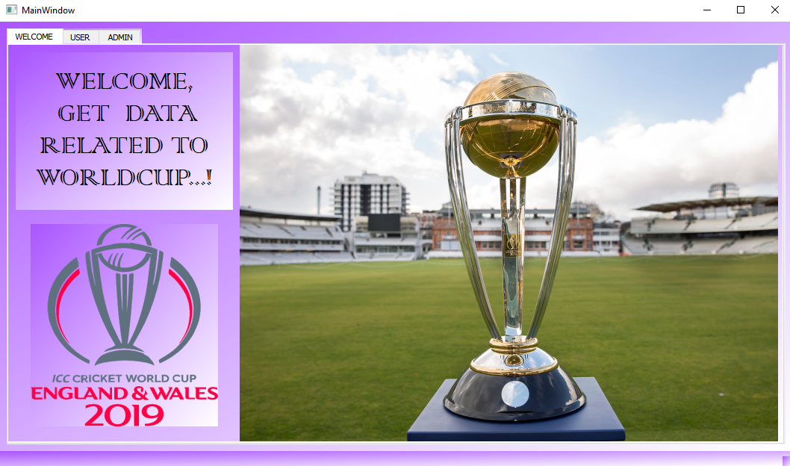

**1.USER**

**1.1 :** open **Teams** tab

If you are a normal user you can get all details about Worldcup in the USER tab.

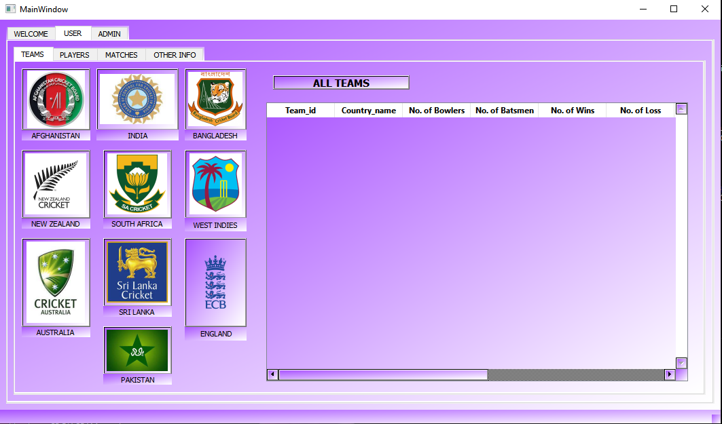

You can click on each **team icon** to get that particular team details.

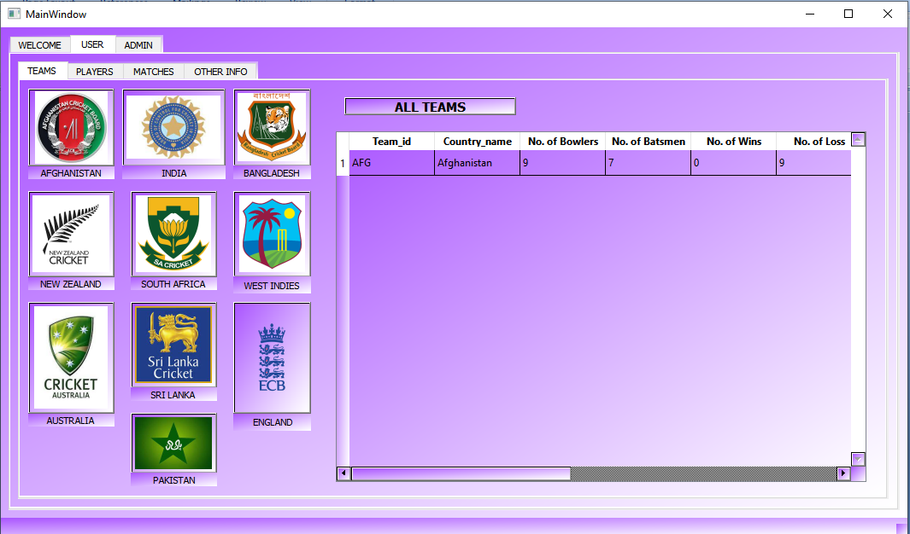

You can click on **All teams to** get info of all teams.

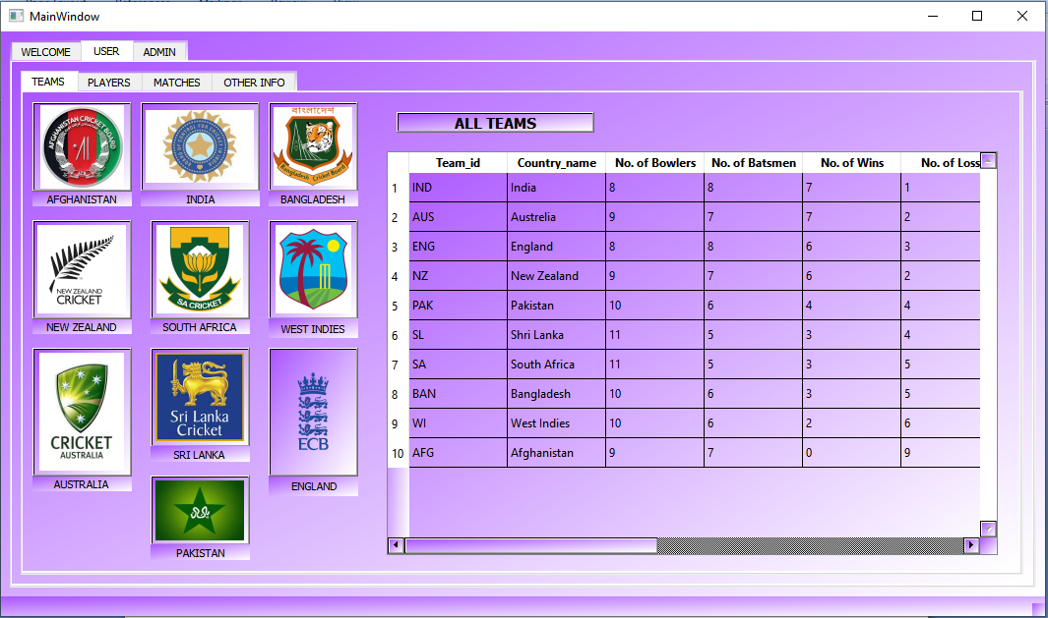

**1.1 :** open **Player** tab

In player tab you can enter team Id and get all players by clicking **All players**,

**Batsmen** and **Bowlers** of a particular team.

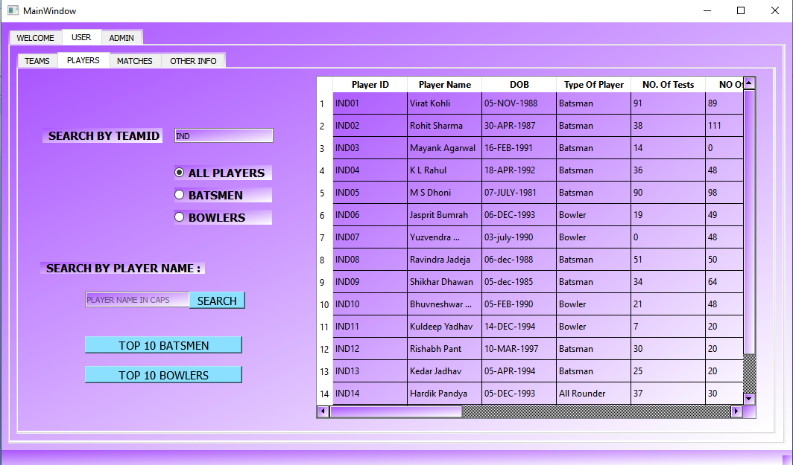

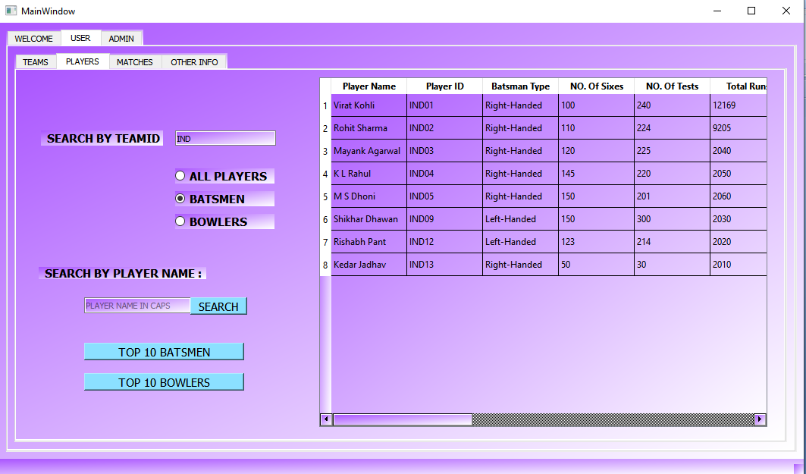

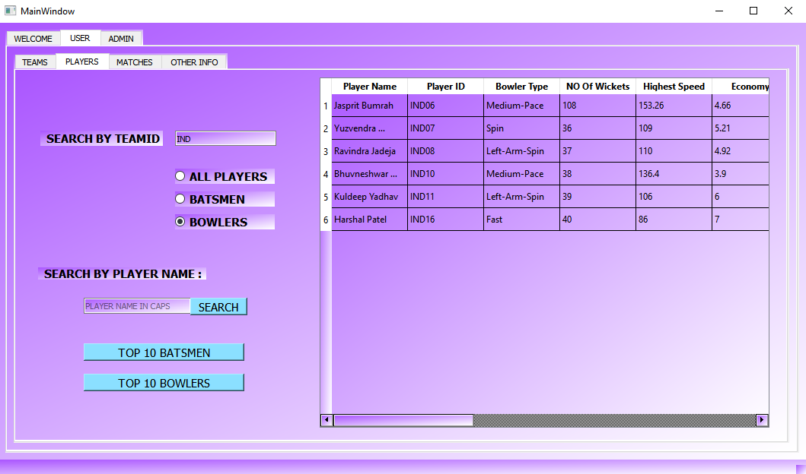

Get details of your favourite player by searching his name .

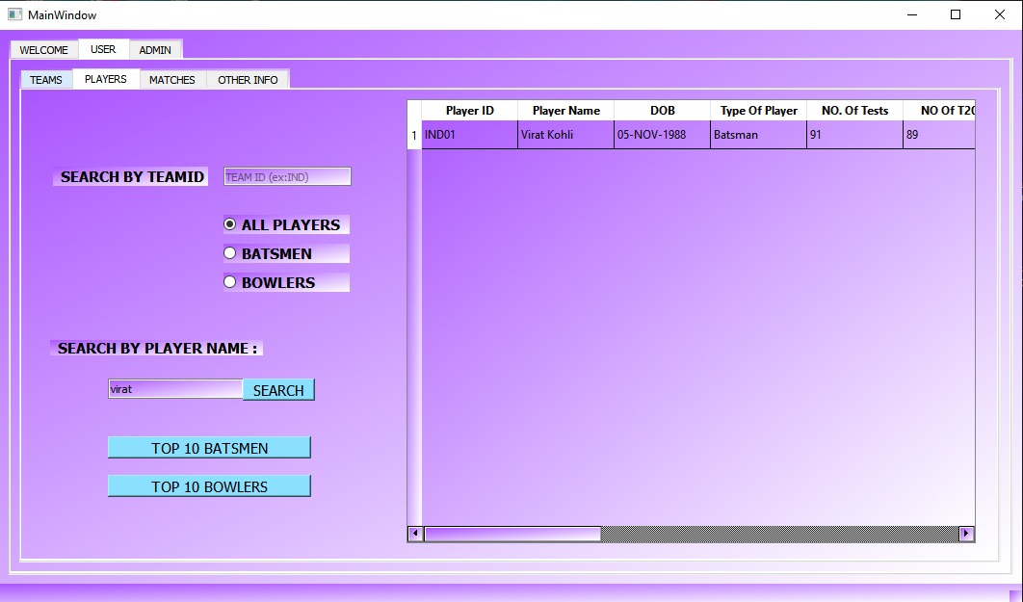

Get **Top 10 batsmen** of the tournament by clicking top 10 batsmen button.

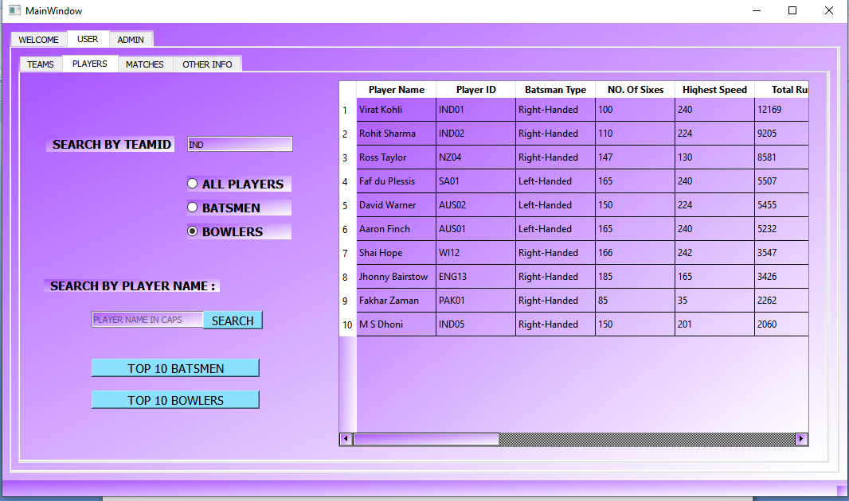

**Top 10 bowlers** of the tournament by clicking top 10 batsmen button.

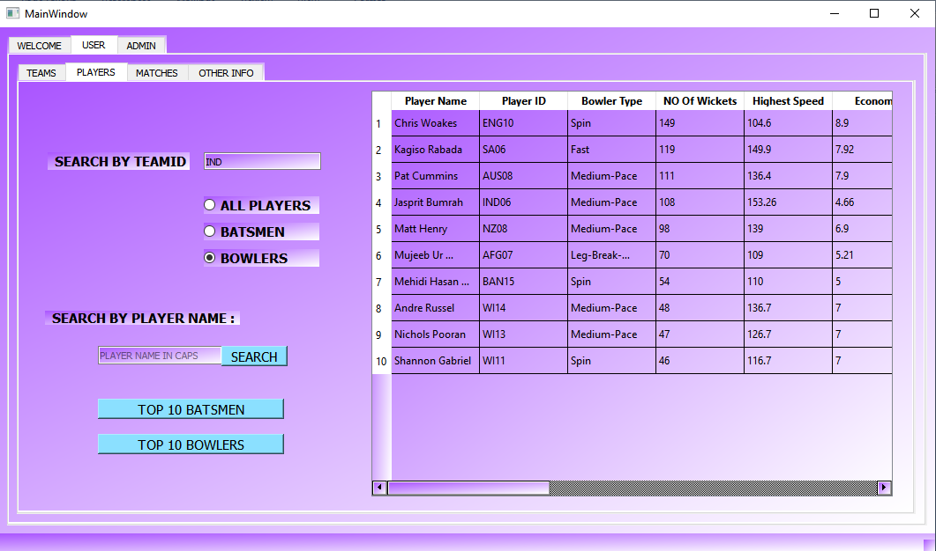

**1.1 :** open **Matches** tab

Get info of all matches by clicking display all matches.

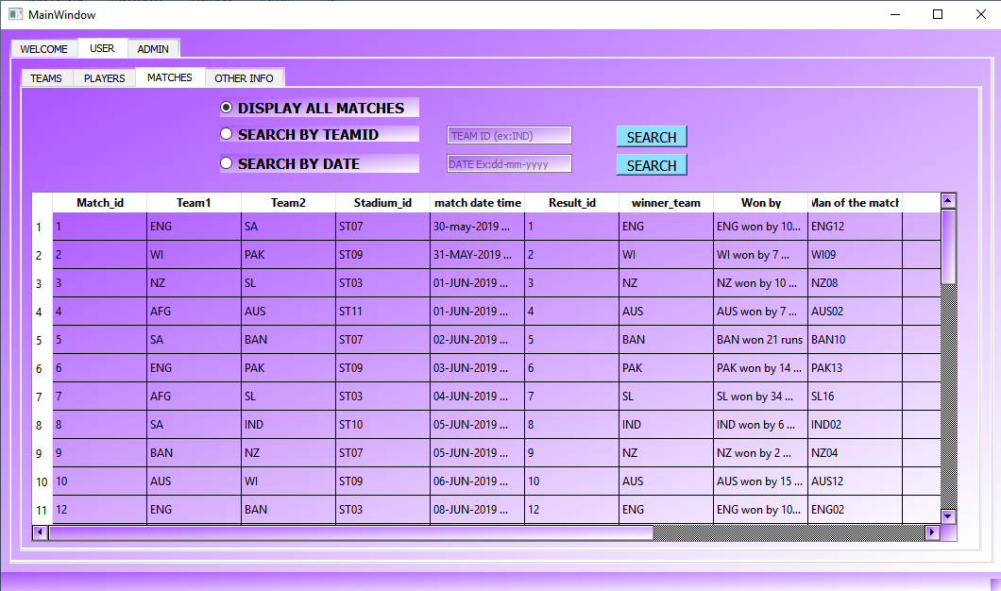

Search your favorite team to check the information of matches and its result.

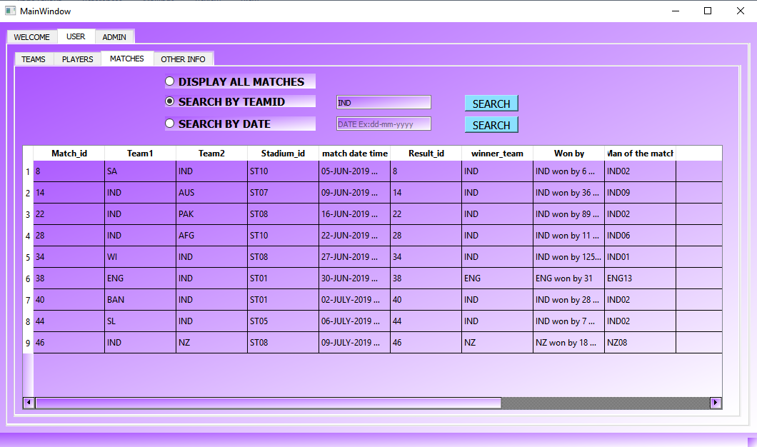

Get match details of a specific date.

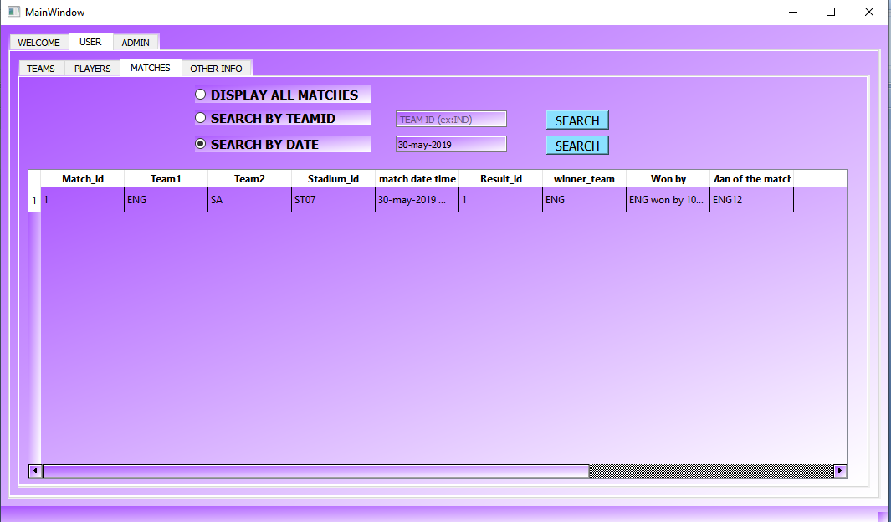

**1.1 :** open **Other Info** tab

click **Display all captains**  to get info of captains of all teams.

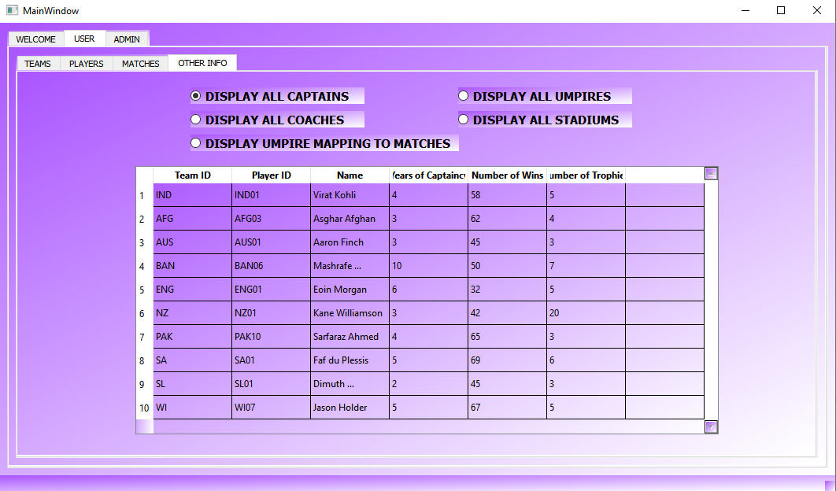

Click **Display all coaches** to get all coaches info.

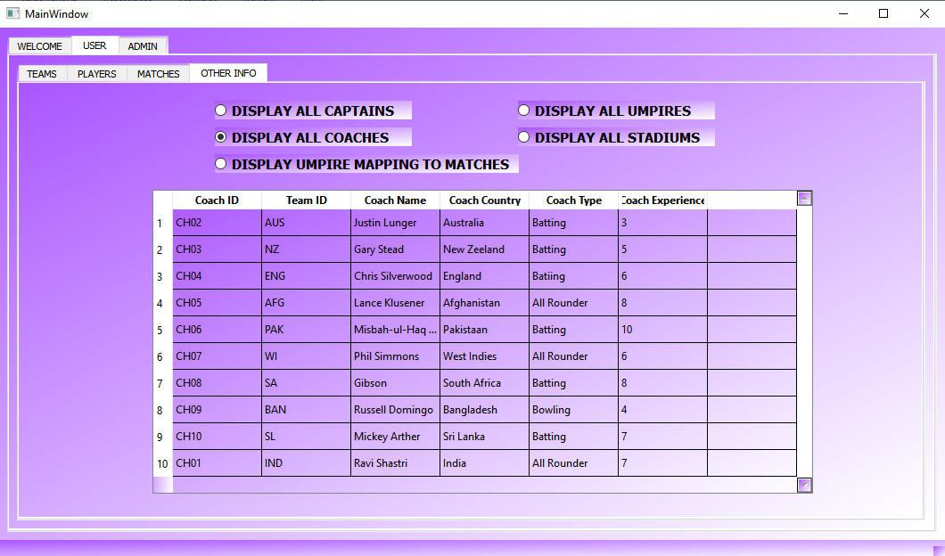

Click **Display umpire matching to matches** to get umpires allocated to all matches.

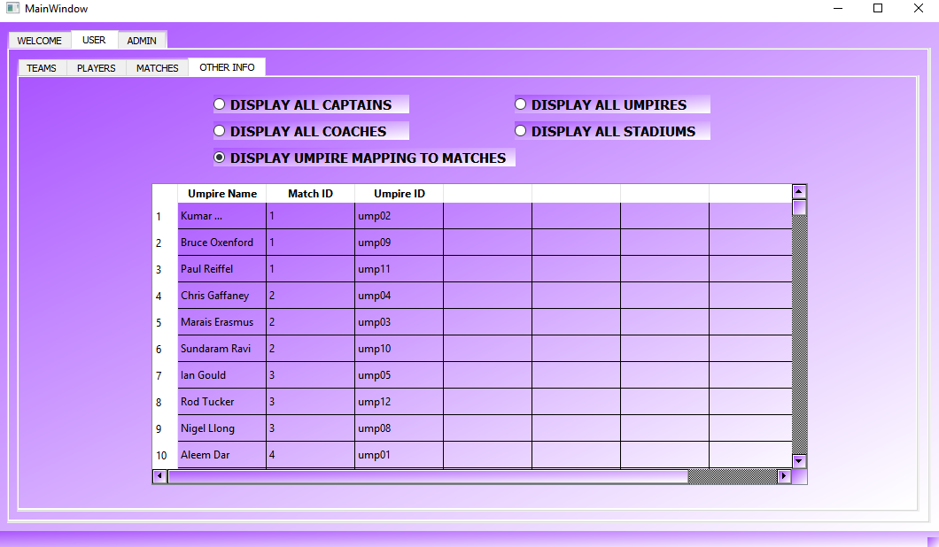

Click **Display all umpires** to get all umpire’s info.

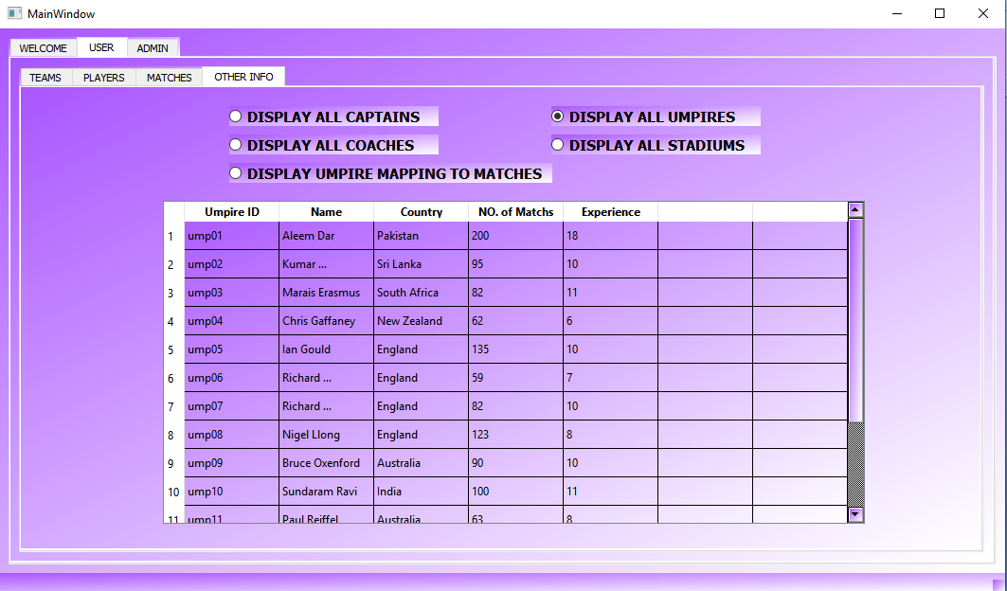

Click **Display all Stadiums** to get all stadiums info where worldcup matches are going to occur.

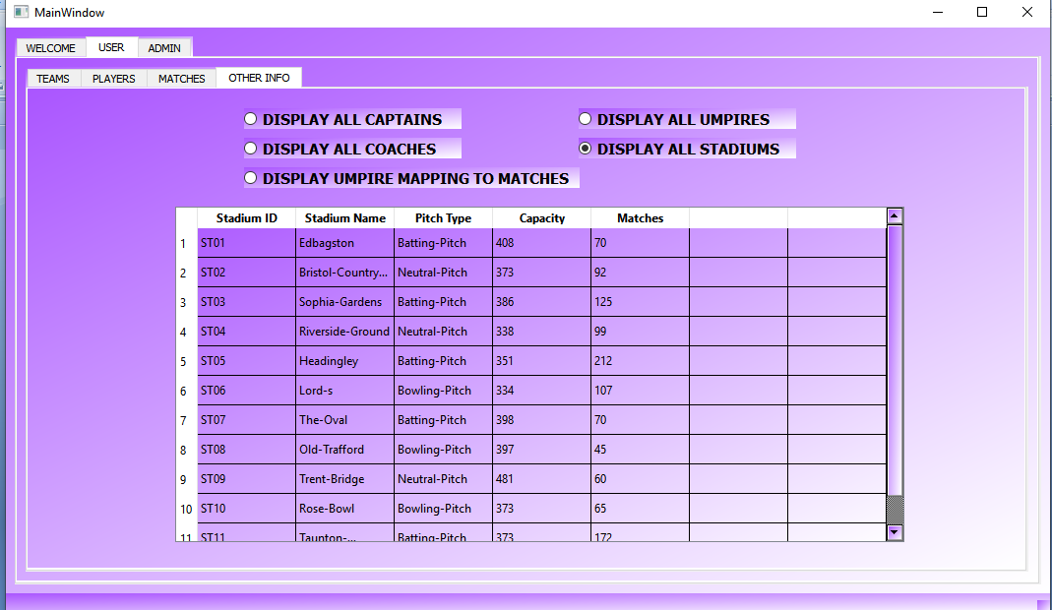

**2.ADMIN**

If you are admin enter your **username(vikram)** and **password( vikky625 )** and click **Login.**

Another window will open where all the admin activities can be done.

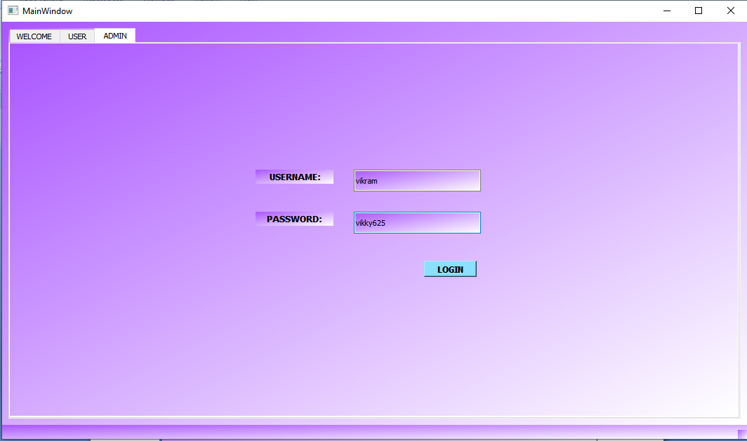

2.1 : Go to **SCHEDULE MATCHES** tab

To schedule a match enter **Team ids** of both teams ,the date and time of match ,it’s venue(stadium) and 3 **umpires** who will umpire the matches

Then click **schedule**. A confirmation message is displayed with match number

Click **ok**.

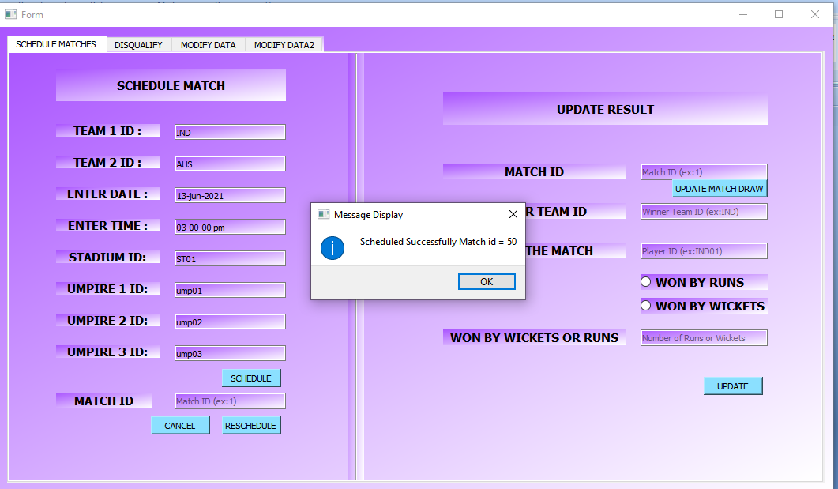

To reschedule a match enter Match ID and date and time and click **reschedule**.

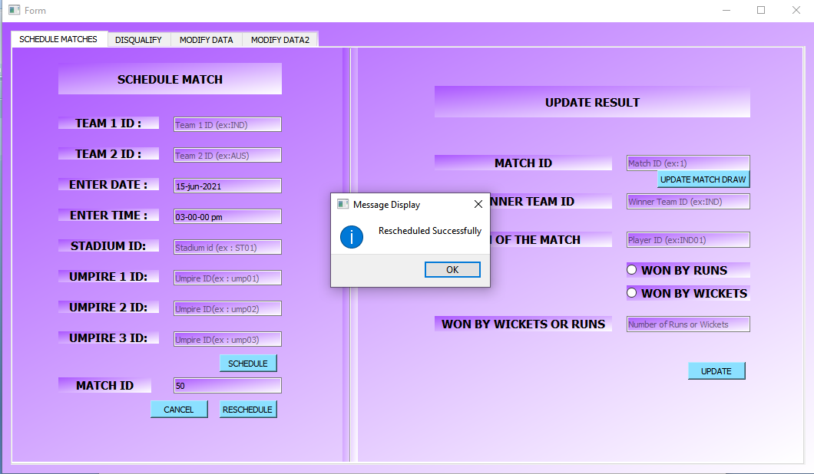

To cancel the match enter Match ID and click **cancel**.

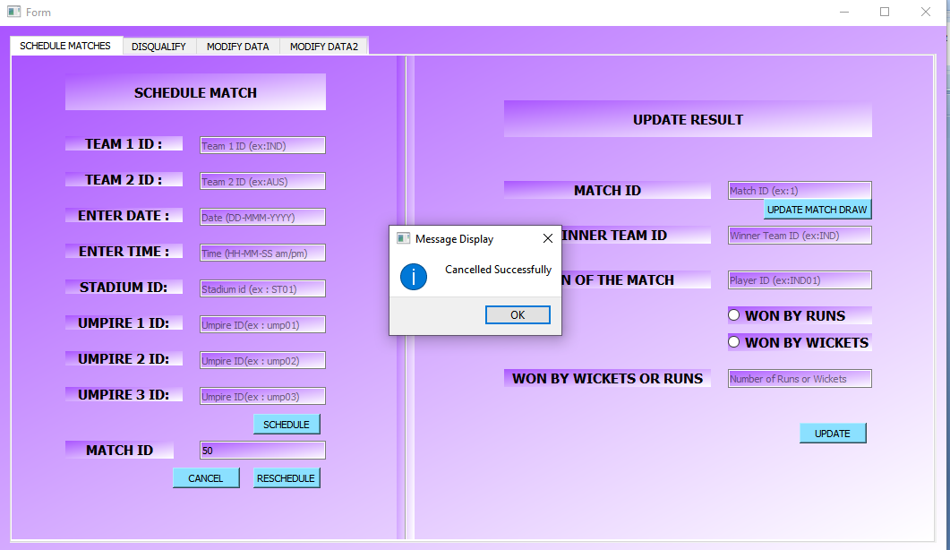

To update the result of a match enter it’s match ID if it is draw click on **update match draw** button. Otherwise enter winner team ID . Select whether they won match by **wickets** or **runs** select respective button.

Enter number of wickets or runs in **Won by wickets** or runs.

Click **update**. The result will be updated.

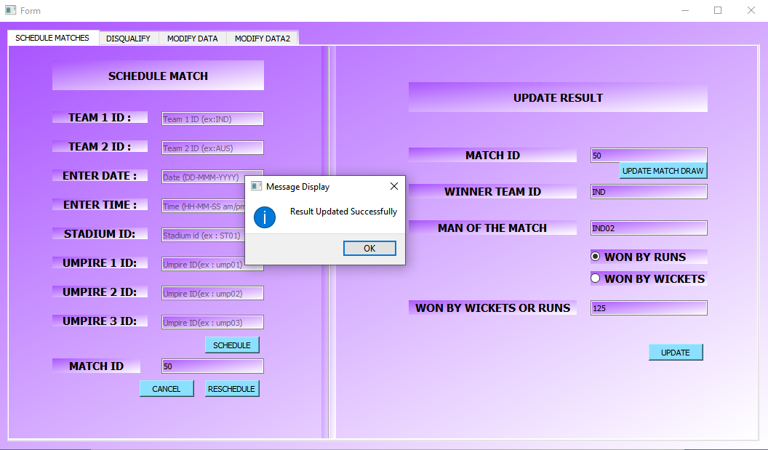

2.1 : Go to **DISQUALIFY** tab

Enter Player ID and click **Go (**that player will be disqualified**)**.

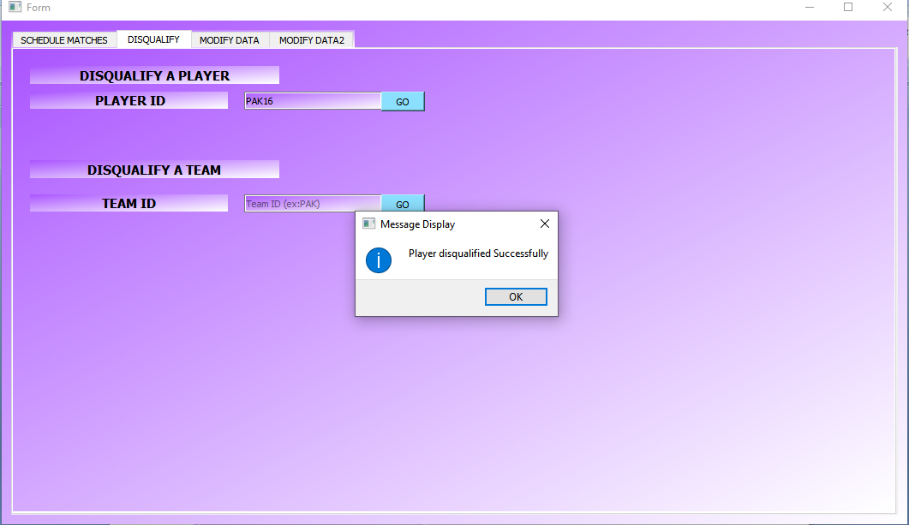

Enter Team ID and click **Go(**that team will be disqualified**)**.

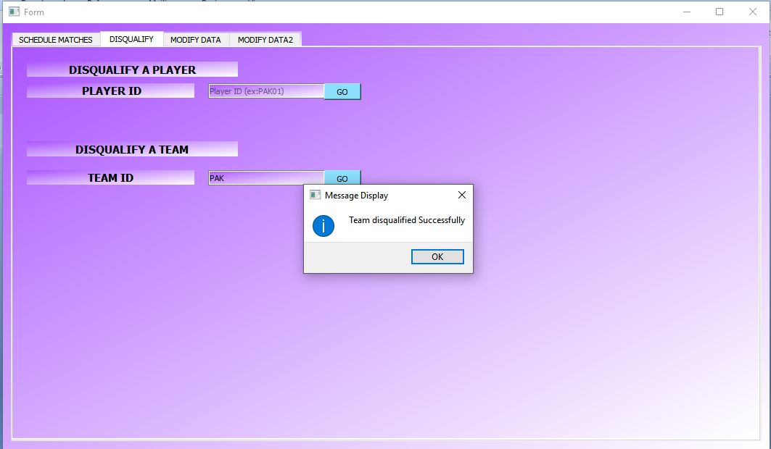

2.3 : Go to **MODIFYDAT1** tab

To add to, update or delete data from database.

Enter the new values of new record to be added and click **insert**.

A message box will be displayerd and your data will be saved.

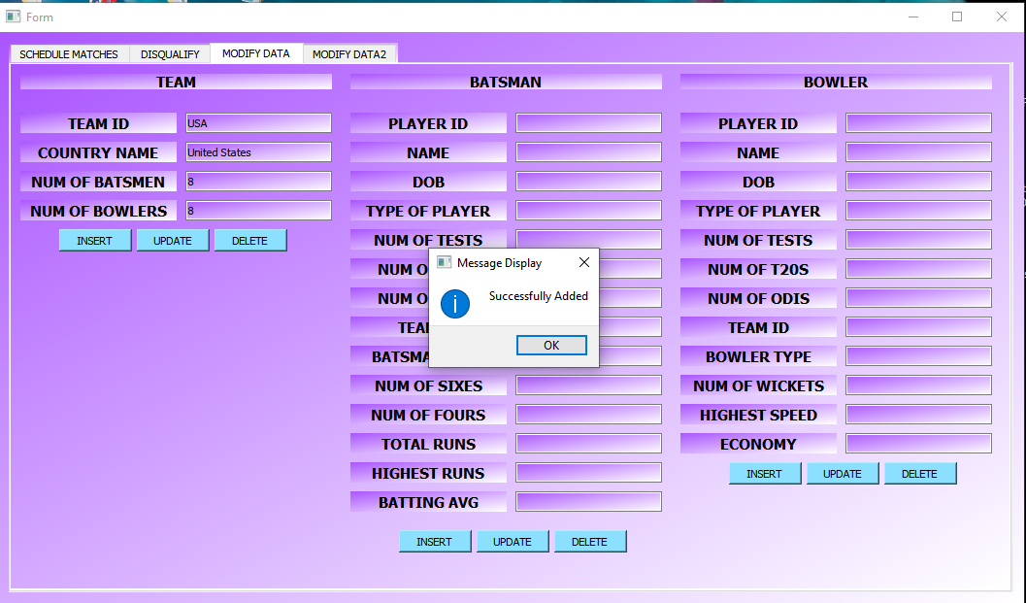

You can also update any table data by entering updated values and click **update**.

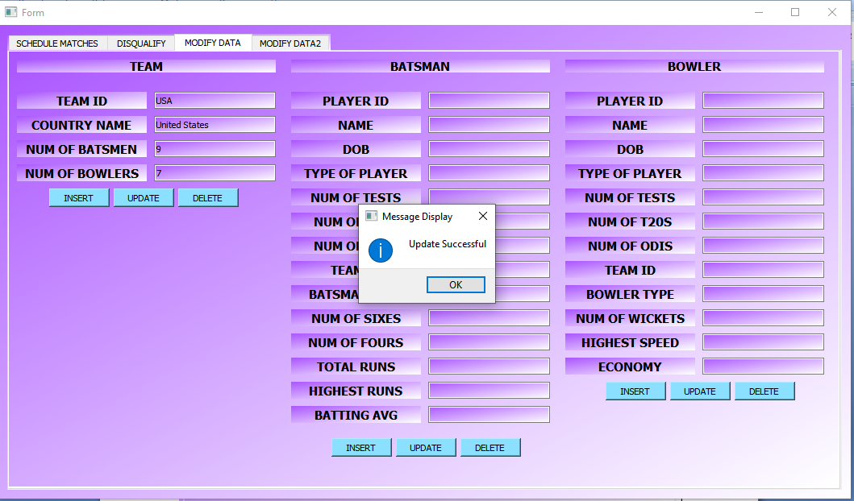

To delete a team Enter a TeamID and click **delete**.

A message box will be displayed and your data will be deleted.

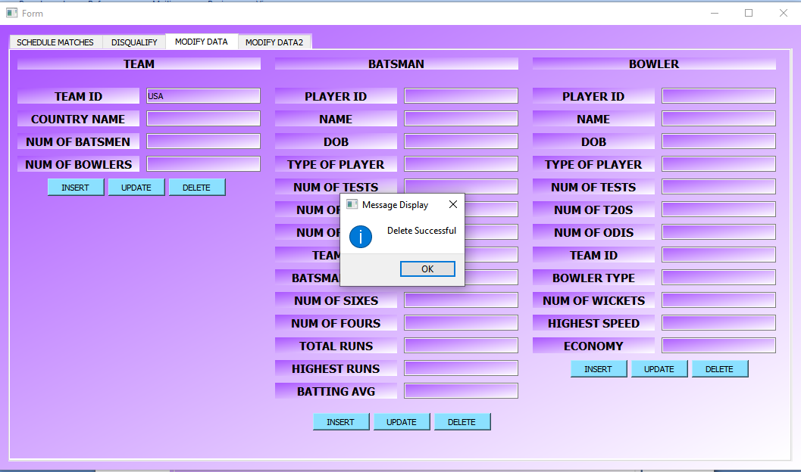

Like this batsmen, bowlers data can also be added modified or deleted.

2.4 : Go to **MODIFYDAT2** tab

Here captains, stadiums, coaches, umpire data can be added modified or deleted like same way you have done to team data.